Name __________________________________________________

5th Grade Modified Math Remote Learning Packet
Week 34

Dear Educator,
My signature is proof that I have reviewed my scholar’s work and supported him to the best of my ability to complete all assignments.

________________________________ ______________________________
(Parent Signature) (Date)
Parents please note that all academic packets are also available on our website at www.brighterchoice.org under the heading “Remote Learning." All academic packet assignments are mandatory and must be completed by all scholars.

Day # 1

Mod 6 Packet 3

Name:__________________________________ Week 34 Day 1 Date:________________
Mod 6 Packet 3
BCCS-Boys Stanford MIT

Do Now
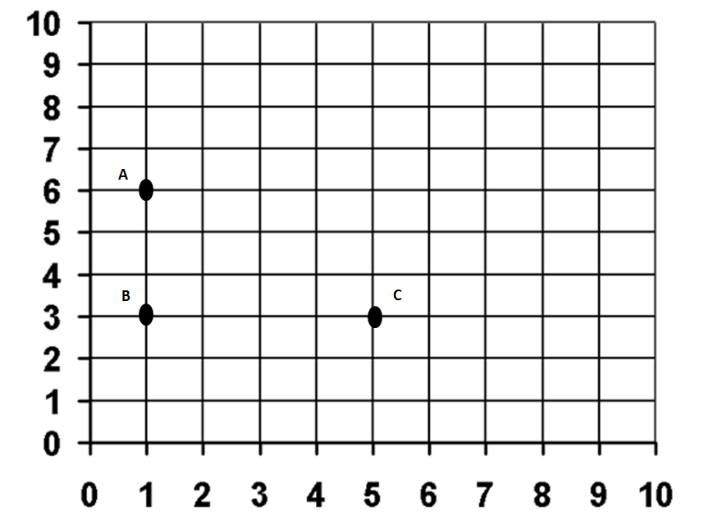
- What are the coordinates of points A, B, and C?
A (______, ______) B (______, ______) C (______, ______)

- Plot point D so that the four points make a rectangle.
- What are the coordinates of point D? ( ______, ______)
- On the same coordinate grid, plot these coordinates:
E ( 7, 6) F (7, 8) G (9, 8) H (9, 6)
- Join the coordinates together. What shape do they make? __________

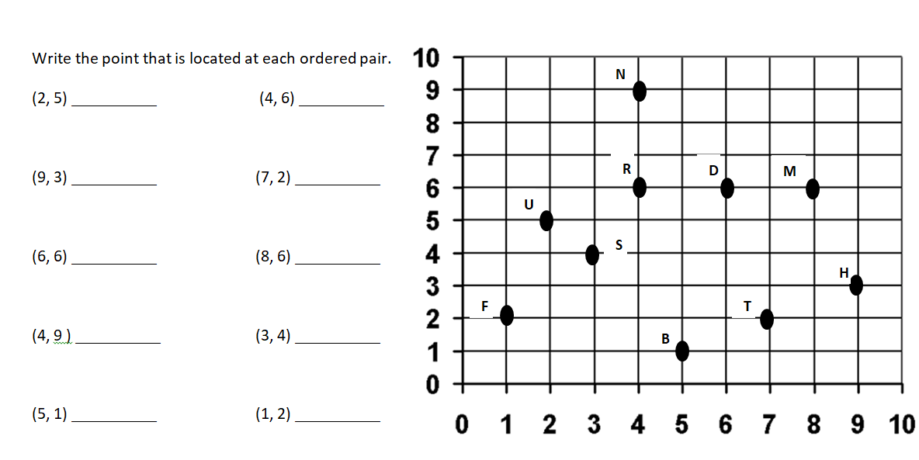
Problem 1

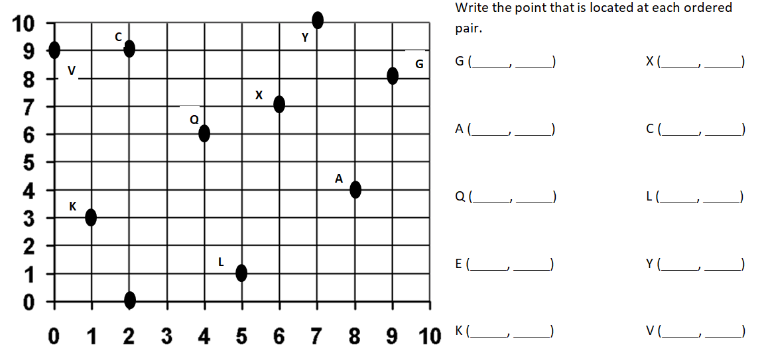
Problem 2

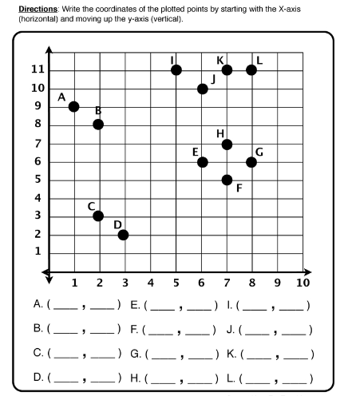
Problem 3

Problem 4
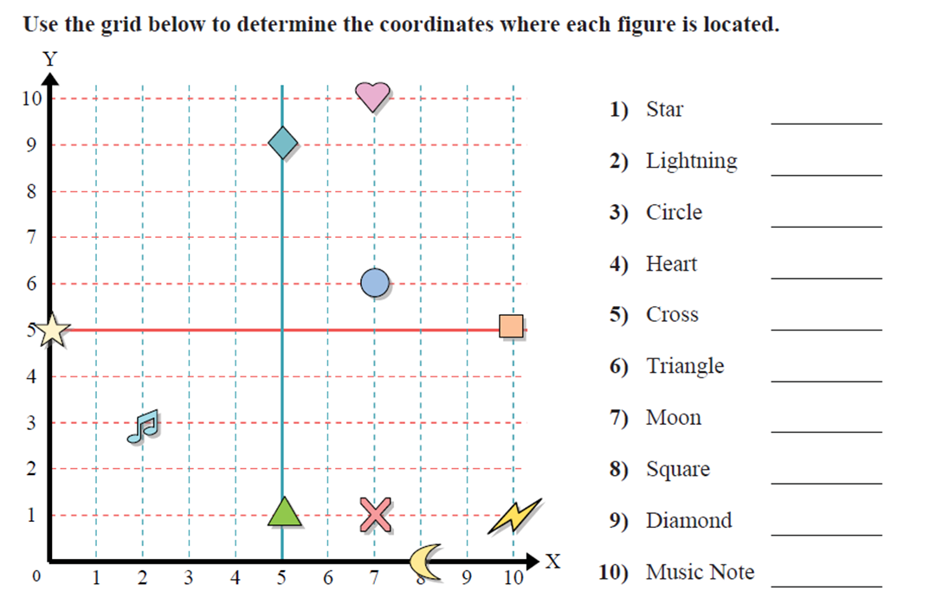

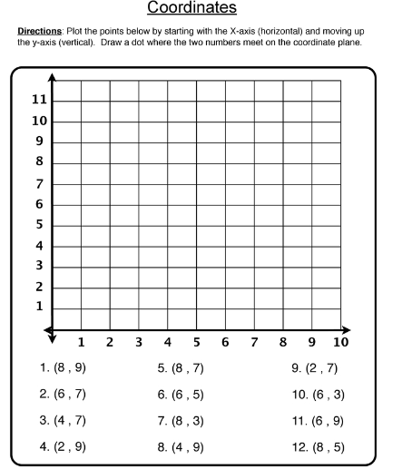
Problem 5

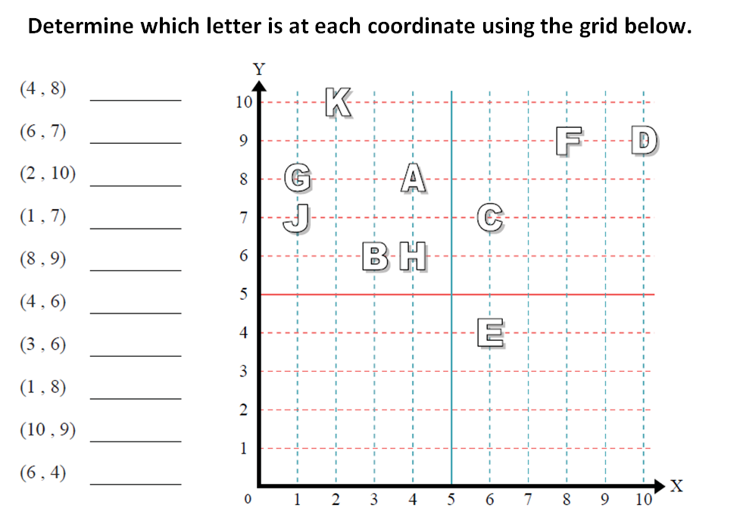
Problem Set

Application Problem
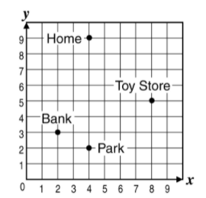
Wesley had a very busy morning. He went to the bank to get some money out. He then proceeded to the toy store to pick up a basketball. After getting his basketball, Wesley went to park to play ball with his friends. After his long day, he finally went back home! What are the locations of each place he stopped at?

Bank ( _____, _____)

Park ( _____, _____)

Toy Store (_____, _____)

Home (_____, _____)

Exit Ticket
Write the ordered pair of each letter on the lines below.
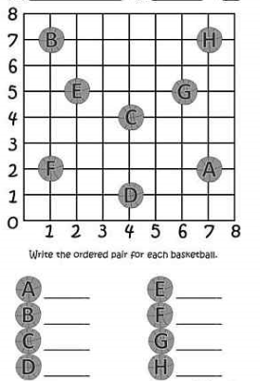

Day # 2

Mod 6 Packet 4

Name:__________________________________ Week 34 Day 2 Date:________________
Mod 6 Packet 4
BCCS-Boys Stanford MIT

Do Now
Name the coordinates of the following letters.

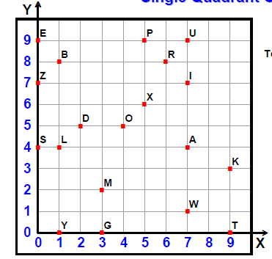
P _______________ W_______________

T _______________ B _______________

Z _______________ A _______________

L _______________ K _______________
Review:
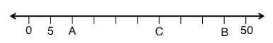

What is the value of A? _____
What is the value of B? _____
What is the value of C? _____

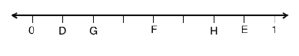

What is the value of D? _____
What is the value of E? _____
What is the value of F? _____
What is the value of G? _____
What is the value of H?_____
What is the value of M? _____
What is the value of N? _____
What is the value of P? _____
What is the value of Q? _____
What is the value of H?_____

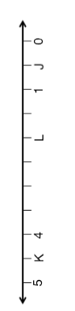

What is the value of J? _____
What is the value of K? _____
What is the value of L? _____

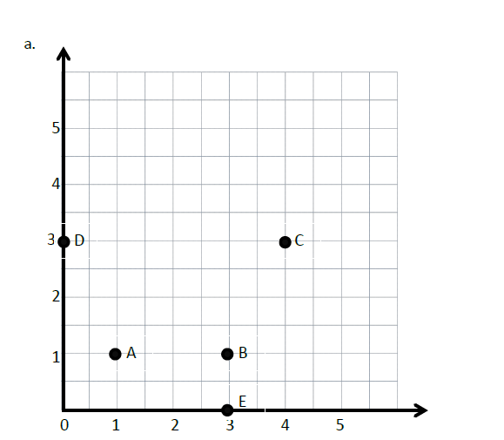
Review:
Write the points for the following:
A _________ B _________
C _________ D _________
E _________

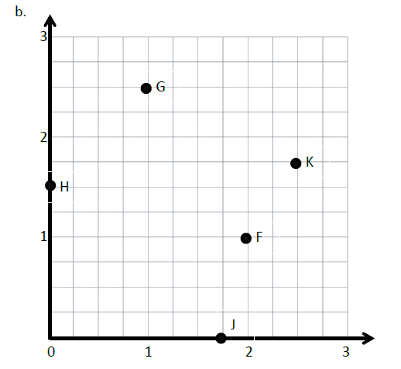
F _________ G _________
H _________ J _________
K _________

Input Activity:
Problem 1:
Construct a coordinate plane.
Creating X and Y Axis
- On the 𝑥-axis, we are going to label the whole numbers only. The length of one square on the grid represents 1 fourth. How many whole numbers can we label?

- Count by fourths with me as we label the whole number grid lines. One fourth …. (Move along the 𝑥-axis while counting, and label every whole number grid line.)

- What is the coordinate of 𝐴? ______________

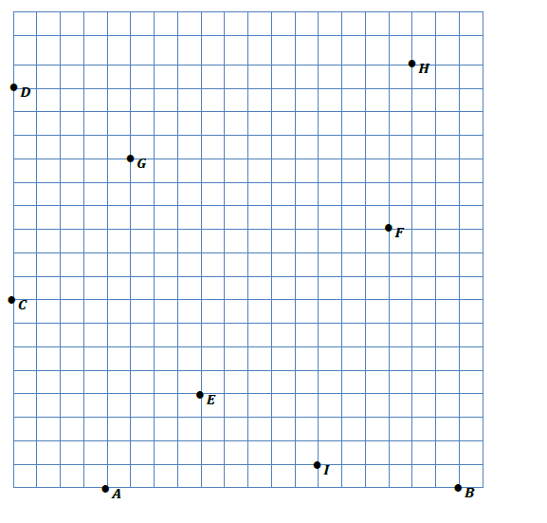

0 $\frac{1}{4} \frac{1}{2} \frac{3}{4 } 1 1\frac{1}{4} 1\frac{1}{2} 1\frac{3}{4} 2 2\frac{1}{4} 2\frac{1}{2} 2\frac{3}{4} 3 3\frac{1}{4} 3\frac{1}{2} 3\frac{3}{4} 4 4\frac{1}{4} 4\frac{1}{2} 4\frac{3}{4} 5$

0 $\frac{1}{4} \frac{1}{2} \frac{3}{4 } 1 1\frac{1}{4} 1\frac{1}{2} 1\frac{3}{4} 2 2\frac{1}{4} 2\frac{1}{2} 2\frac{3}{4} 3 3\frac{1}{4} 3\frac{1}{2} 3\frac{3}{4} 4 4\frac{1}{4} 4\frac{1}{2} 4\frac{3}{4} 5$

Problem 2
Use coordinate pairs to name and plot points.
Let’s label the coordinate pairs with the X axis first, then the Y axis second.
Letter | X Axis | Y Axis | Coordinate ( , )
A
B
C
D
E
F
G
H
I

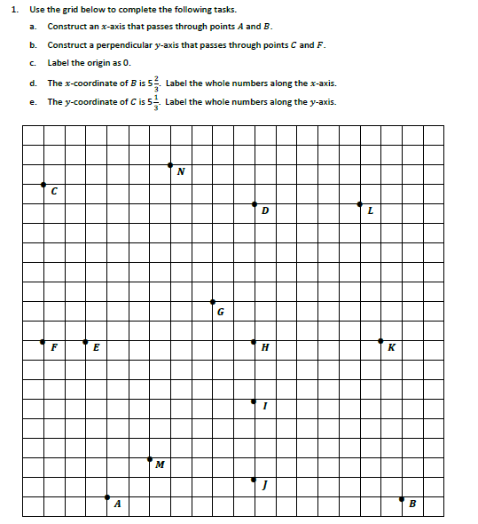
Problem Set

0 $\frac{1}{3} \frac{2}{3} 1 1\frac{1}{3} 1\frac{2}{3} 2 2\frac{1}{3} 2\frac{2}{3} 3 3\frac{1}{3} 3\frac{2}{3} 4 4\frac{1}{3} 4\frac{2}{3} 5 5\frac{1}{3} 5\frac{2}{3} 6 6\frac{1}{3}$

0 $\frac{1}{3} \frac{2}{3} 1 1\frac{1}{3} 1\frac{2}{3} 2 2\frac{1}{3} 2\frac{2}{3} 3 3\frac{1}{3} 3\frac{2}{3} 4 4\frac{1}{3} 4\frac{2}{3} 5 5\frac{1}{3} 5\frac{2}{3} 6 6\frac{1}{3}$
2. Identify all of the points that have an x-coordinate of $3\frac{1}{3}.$
__________________________________________________________

3. Identify all of the points that have a y-coordinate of $2\frac{2}{3}.$
__________________________________________________________

4. Which point is located at $(3\frac{1}{3}$ , $2\frac{2}{3}$ ) ?_______ at ($5\frac{1}{3}$, $2\frac{2}{3}$)?_______

at $(1\frac{2}{3},\frac{2}{3})$ ?_________

7. Give the coordinate pair for each of the following points.
K:__________ I: __________ B:__________ C:__________

8. Name the points located at the following coordinates.
$\left(1\frac{2}{3},\frac{2}{3}\right)$_______ $\left(0, 2\frac{2}{3}\right)$_______ $\left(1,0\right)$ _______ $\left(2, 5\frac{2}{3}\right)$______

9. Which point has an equal x and y coordinate?___________________

10. Plot the following points.
P: $\left(4\frac{1}{3}, 4\right)$ Q$:\left(\frac{1}{3}, 6\right)$ R:$\left(4\frac{2}{3}, 1\right)$ S:$\left(0, 1\frac{2}{3}\right)$
Application Problem:

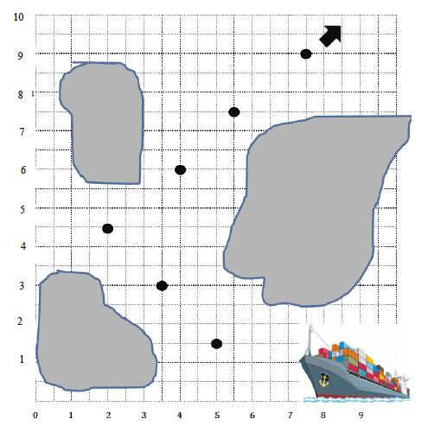
The captain of a ship has a chart to help him navigate through the islands. He must follow points that show the deepest part of the channel. List the coordinates the captain needs to follow in the order he will encounter them.

1. (____, ____) 2. (____, ____) 3. (____, ____)

4. (____, ____) 5. (____, ____) 6. (____, ____)

Exit Ticket
Use a ruler on the grid below to construct the axes for a coordinate plane. The 𝑥-axis should intersect points 𝐿 and 𝑀. Construct the 𝑦-axis so that it contains points 𝐾 and 𝐿. Label each axis.
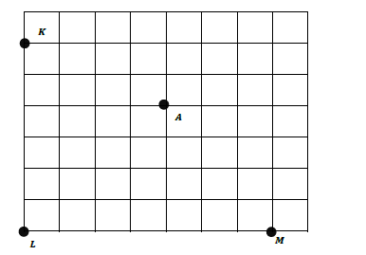
0 $\frac{1}{4} \frac{1}{2} \frac{3}{4} 1 1\frac{1}{4} 1\frac{1}{2} 1\frac{3}{4}$

0 $\frac{1}{4} \frac{1}{2} \frac{3}{4} 1 1\frac{1}{4} 1\frac{1}{2} 1\frac{3}{4} 2$

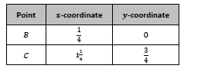

What letter is located at $(0 , 1\frac{1}{2})$?____________
What letter is located at $(1\frac{3}{4}, 0)$? ___________

Day # 3

Mod 6 Packet 5

Name:__________________________________ Week 34 Day 3 Date:________________
Mod 6 Packet 5
BCCS-Boys Stanford MIT

Do Now
Help the animal reach its food by plotting points and connecting them with lines.
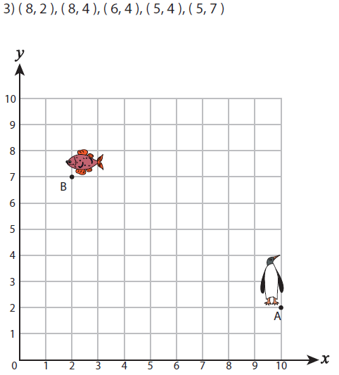

Review:
What is the value of M? _____
What is the value of N? _____
What is the value of P? _____
What is the value of Q? _____
What is the value of H?_____

What is the value of J? _____
What is the value of K? _____
What is the value of L? _____

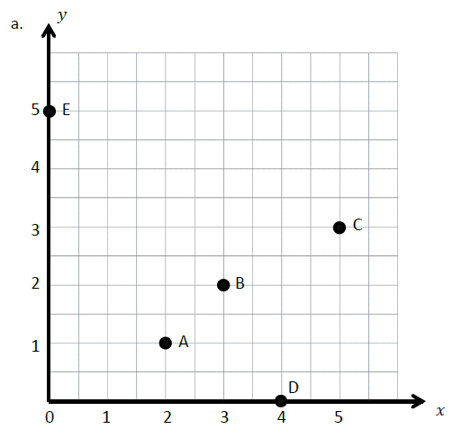
Review:
Write the points for the following:
A _________ B _________
C _________ D _________
E _________

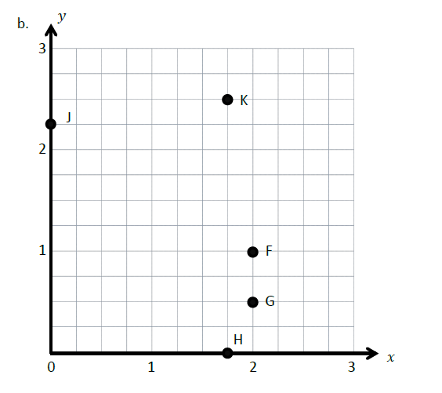

F _________ G _________
H _________ J _________
K _________

Input Activity
Problem 1:
- Label the x and y axis, the origin, and the number lines.
- Plot point A at $\left(2\frac{1}{2}, 1\frac{1}{4}\right).$
- Construct a line, ℓ, so that it contains 𝐴 and is perpendicular to the 𝑥-axis. (draw the line)
- Give the coordinates for another point on line ℓ that is $1\frac{1}{2}$ units farther from the 𝑥-axis than 𝐴. Label it 𝐵.

- Name the coordinates of 𝐵. (_____, _____)
- Give the coordinates for the point on ℓ that is halfway between 𝐴 and 𝐵.
(_____, _____)
- Label is C.
- Now, draw a line, , that is perpendicular to line ℓ and $\frac{1}{2}$ unit from the 𝑥-axis. (Draw the line.)
- Plot a point, 𝐷, where lines ℓ and 𝓂 intersect.
- Plot a point, 𝐸, on line 𝓂 that is $\frac{3}{4}$ unit from the 𝑦-axis. Then, record the coordinates of 𝐸 in the chart.
- Name the coordinates of 𝐸. (_____, _____)
- Plot a point 𝐹 on line 𝓂 that is $\frac{3}{4}$ unit farther from the 𝑦-axis than 𝐸. Then, record the coordinates of 𝐹 in the chart.
- Plot a point 𝐹 on line 𝓂 that is $\frac{3}{4}$ unit farther from the 𝑦-axis than 𝐸. Then, record the coordinates of 𝐹 in the chart. (Plot 𝐹 and record.)
- Use your straightedge to construct a line, 𝓃, which is parallel to line ℓ and contains point 𝐹.
- Name the 𝑥-coordinate for every point on line 𝓃. _____________

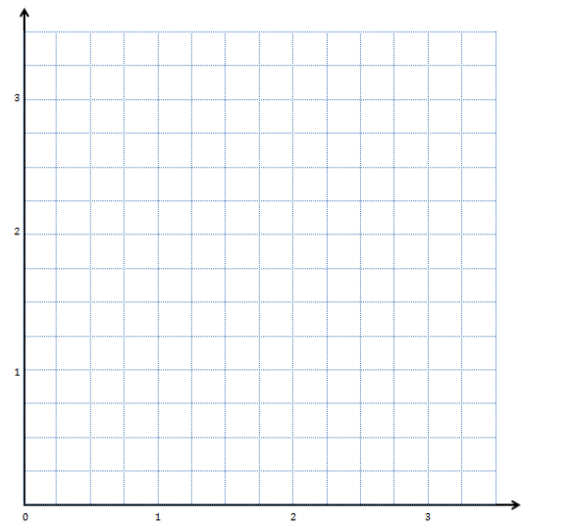
$$1\frac{1}{2}$$
$$3\frac{1}{4}$$
$$2\frac{3}{4}$$
$$1\frac{1}{2}$$
$$2\frac{1}{4}$$
$$1\frac{3}{4}$$
$$1\frac{1}{2}$$
$$1\frac{1}{4}$$
$$\frac{3}{4}$$
$$\frac{1}{2}$$
$$\frac{1}{4}$$
$$3\frac{1}{2}$$
$$2\frac{1}{2}$$
$$1\frac{1}{2}$$
$$3\frac{1}{4}$$
$$2\frac{1}{4}$$
$$1\frac{1}{4}$$
$$2\frac{3}{4}$$
$$1\frac{3}{4}$$
$$\frac{3}{4}$$
$$\frac{1}{4}$$
$$\frac{1}{2}$$
Point | X | Y | (x,y)
A | $$2\frac{1}{2}$$ | $$1\frac{1}{4}$$
B
C
D
E
F

Problem Set:
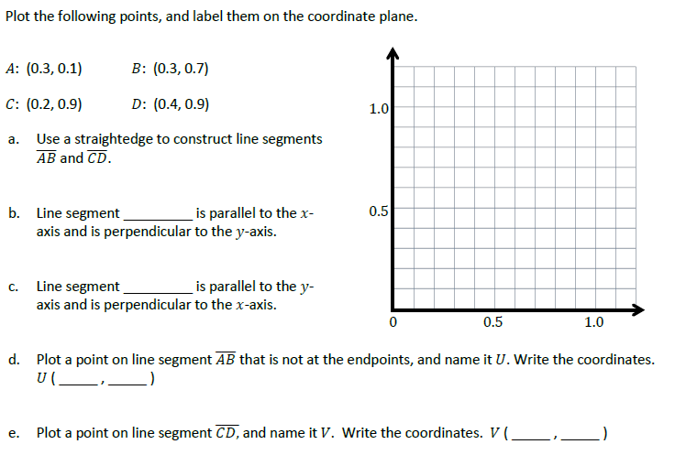

Application Problem:

Naomi lives at Second Avenue and Third Street represented by (2,3) on the graph below. Her school is a Fourth Avenue and 10th Street represented by (4, 10) on the graph. She walks over to Fourth Avenue and up to 10 Street. Plot her home and school on the map.

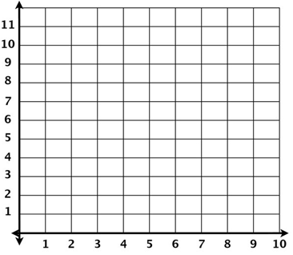

How many blocks did Naomi walk to school? __________

Exit Ticket
Plot the given points in the following order, connect them and help the trumpeter find his musical trumpet.
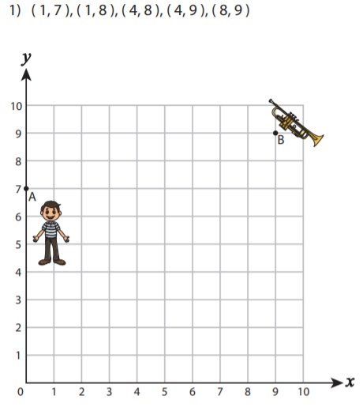

Answer: ________ boats

Day # 4

Mod 6 Packet 6

Name:__________________________________ Week 34 Day 4 Date:________________
NYS Math Review Packet 3
BCCS-Boys Stanford MIT
Do Now
Help the animal reach its food by plotting points and connecting them with lines.
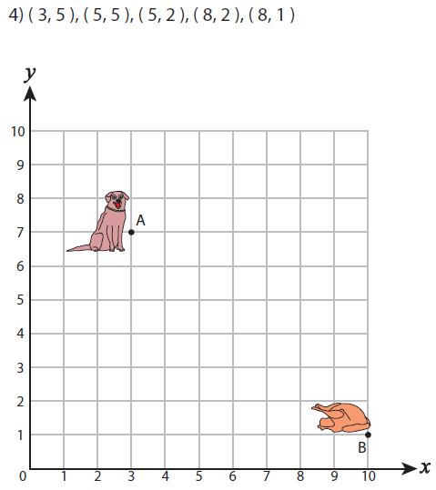

Review:
Use Decimals
What is the value of B? _____
What is the value of C? _____
What is the value of A? _____

What is the value of H?_____

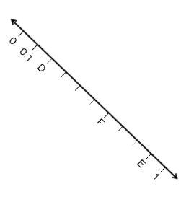

What is the value of D? _____
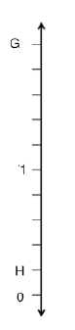
What is the value of F? _____
What is the value of E? _____

What is the value of G? _____
What is the value of H? _____

What is the value of H?_____

Input Activity
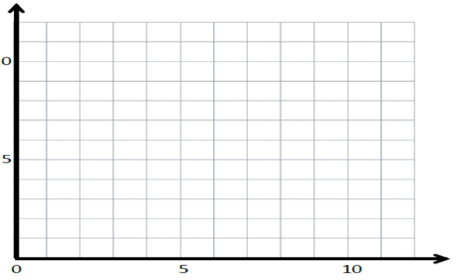
Problem 1

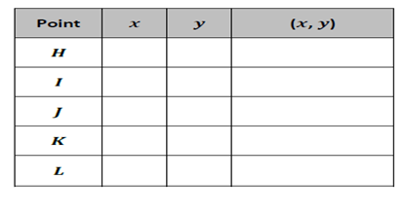

- Plot a point, 𝐻, which is 3 units from the 𝑥-axis and 4 units from the 𝑦-axis. Write its coordinates on the chart.

- Plot I at (10, 3) and write its coordinates on the chart. Plot J at (8, 3) and write its coordinates on the chart.

- What do you notice about these points and their coordinates?_______________
__________________________________________________________________

- Draw a straight line going through H, I , and J. Label it w. What do you notice about this line? ____________________________________________________
Will this line ever intersect the x axis?________

- Finish this sentence Line w is ____________to the x-axis.

- Does w intersect with the y axis?_______ Give the coordinates of the intersection (____,____)

- What kind of angle is formed at the intersection of line w and the y axis? _______

- What is the name for intersecting lines that form right angles?_______________

- Finish this sentence: Line w is perpendicular to the _______axis.

- Plot points 𝐾 and 𝐿 so that they are on line 𝓌; then, record their coordinates in the chart.

- Let’s make two more lines parallel to w. One higher labeled p and one lower labeled q.

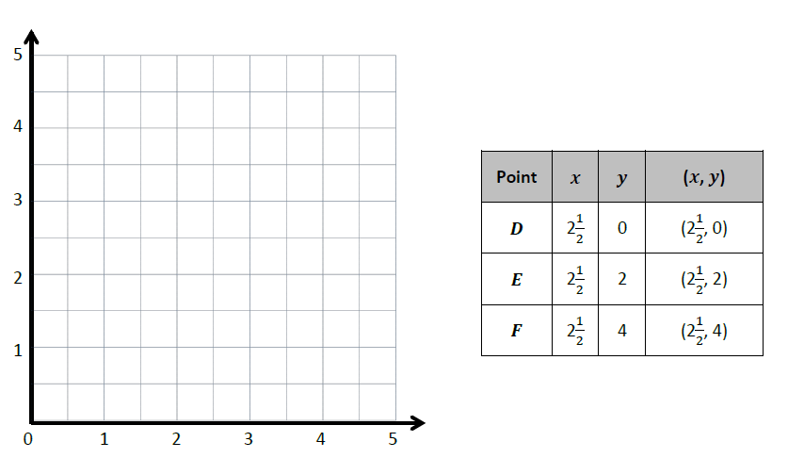
Problem 2

- Plot D, E, and F on the grid.

- Draw a straight line going through D, E , and F. Label it m. What do you notice about this line? ___________________________________________________

- Will this line ever intersect the y axis?________

- Finish this sentence Line m is _______________to the y-axis.
- Let’s make one more line parallel to m. Let’s label it n.

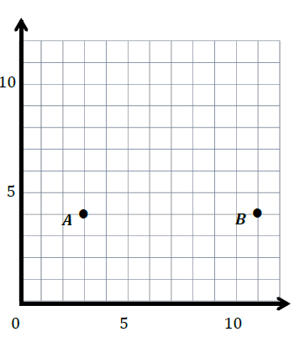
Problem 3:

Use the coordinate plane to the right to answer the following questions.

a. Use a straightedge to construct a line that goes through points 𝐴 and 𝐵.
Label the line 𝑒.

b. Line 𝑒 is parallel to the ______-axis and is perpendicular to the ______-axis.

c. Plot two more points on line 𝑒. Name them 𝐶 and 𝐷.

d. Give the coordinates of each point below.
𝐴: ________ 𝐵: ________
𝐶: ________ 𝐷: ________

e. What do all of the points of line 𝑒 have in common? ________________

_______________________________

f. Give the coordinates of another point that would fall on line 𝑒 with an 𝑥-coordinate greater than 15.

Problem Set:
- Plot the following points on the coordinate plane on the following page.
P :($1\frac{1}{2},\frac{1}{2}$) 𝑄: ($1\frac{1}{2}, 2\frac{1}{2}$) 𝑅: ($1\frac{1}{2}, 1\frac{1}{4}$) 𝑆: ($1\frac{1}{2},\frac{3}{4}$)
a. Use a straightedge to draw a line to connect these points. Label the line 𝒽.
b. In line 𝒽, 𝑥 = _____ for all values of 𝑦.
c. Circle the correct word.
Line 𝒽 is parallel perpendicular to the 𝑥-axis.
Line 𝒽 is parallel perpendicular to the 𝑦-axis.
d. What pattern occurs in the coordinate pairs that let you know that line 𝒽 is vertical?
2. For each pair of points below, think about the line that joins them. For which pairs is the line parallel to the 𝑥-axis? Circle your answer.
a. (1.4, 2.2) and (4.1, 2.4) b. (3, 9) and (8, 9) c. ($1\frac{1}{4}, 2$) and ($1\frac{1}{4},8$)

3. For each pair of points below, think about the line that joins them. For which pairs is the line parallel to the 𝑦-axis? Circle your answer.
a. (4, 12) and (6, 12) b. ($\frac{3}{5}, 2\frac{3}{5}$) and ($\frac{1}{5}, 2\frac{3}{5}$) c. (0.8, 1.9) and (0.8, 2.3)

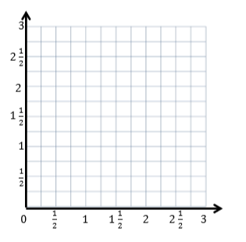

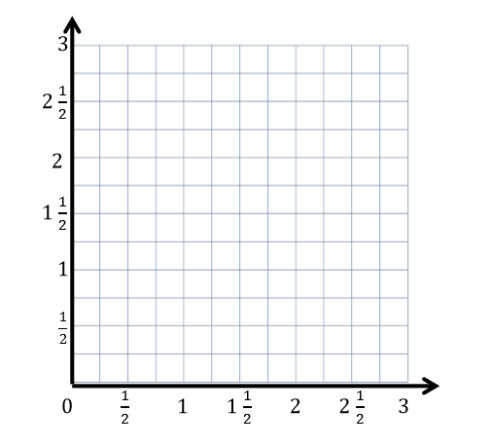
Application Problem:

- Plot the following points on the coordinate plane to the right.
𝐻: ( $\frac{3}{4},3$) 𝐼: ($\frac{3}{4},2\frac{1}{4}$) 𝐽 : ($\frac{3}{4},\frac{1}{2}$) 𝐾: ($\frac{3}{4}, 1\frac{3}{4}$)
- Use a straightedge to draw a line to connect these points. Label the line z.

b. In line z, 𝑥 = ______ for all values of 𝑦.

- Circle the correct word:
Line z is parallel perpendicular to the 𝑥-axis.

Line z is parallel perpendicular to the 𝑦-axis.

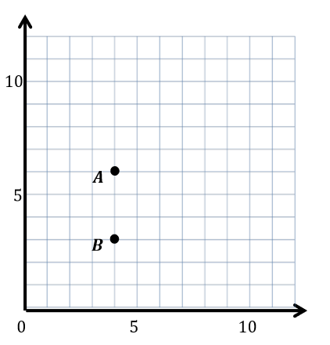
Exit Ticket

- Use a straightedge to construct a line that goes through points 𝐴 and 𝐵. Label the line ℓ.

- Which axis is parallel to line ℓ? ____________________

- Which axis is perpendicular to line ℓ? ____________________

- Plot two more points on line ℓ. Name them 𝐶 and 𝐷.

- Give the coordinates of each point below.
𝐴: ___________ 𝐵: ___________ 𝐶: ___________ 𝐷: ___________

Day # 5

Mod 6 Packet 7

Name:__________________________________ Week 34 Day 5 Date:________________
Mod 5 Packet 7
BCCS-Boys Stanford MIT
Do Now
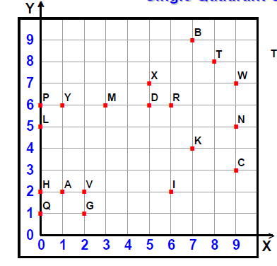

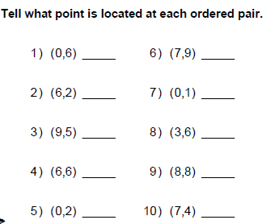

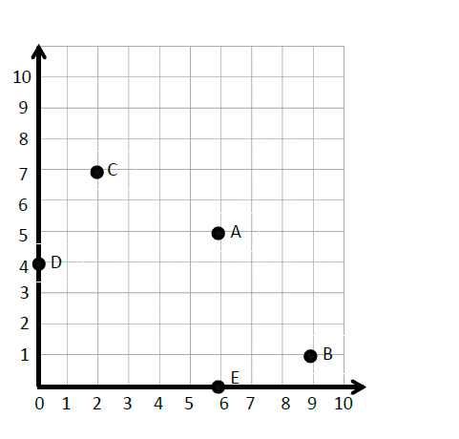
Review:
Write the coordinates for the following:
C _________________
A _________________
B _________________
D _________________
E _________________

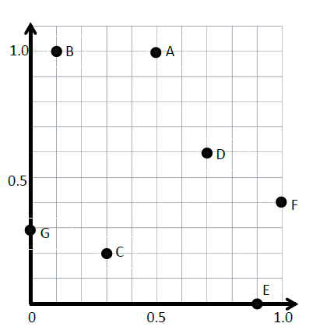
Write the coordinates for the following:
B _________________
D _________________
A _________________
G _________________
C _________________
E _________________
F _________________

Input Activity
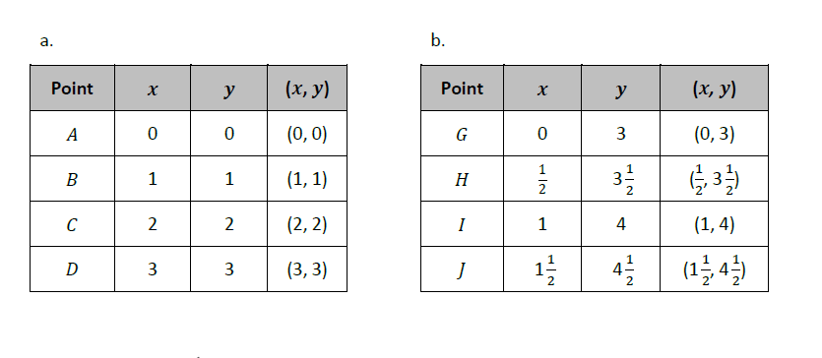
Problem 1

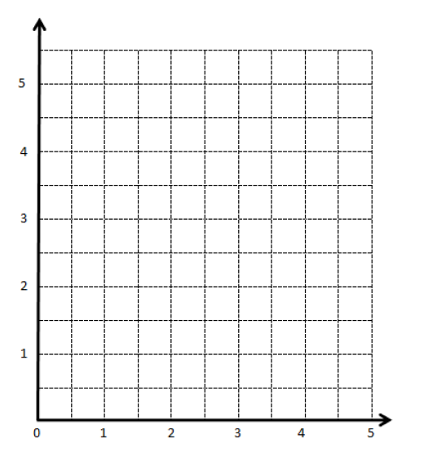

Problem 2
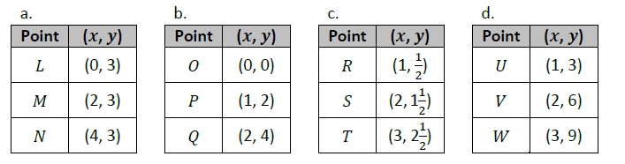

- Which chart shows coordinate pairs for the rule 𝑦 is always 3? _______ Write the rule underneath that chart.

- Which chart shows every 𝑦-coordinate is less than every x-coordinate?_______ How much less? _________

- What is the rule?_______________________________ Write it underneath that chart.

- Which chart shows coordinate pairs on a line that follows the rule 𝑦 is 𝑥 times 2?________ Write the rule underneath that chart.

- Let’s come up with a rule for the final chart __________________ Write the rule underneath that chart.

Problem 3

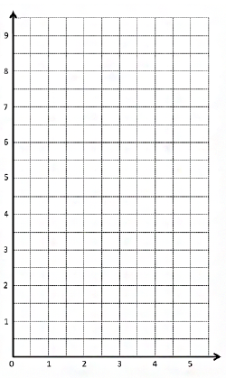
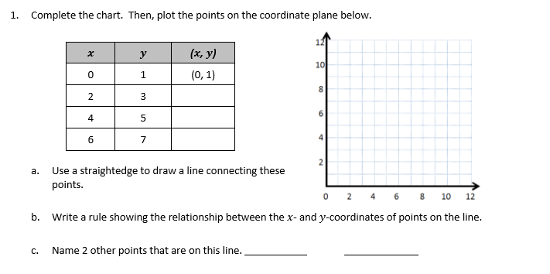
Problem Set:

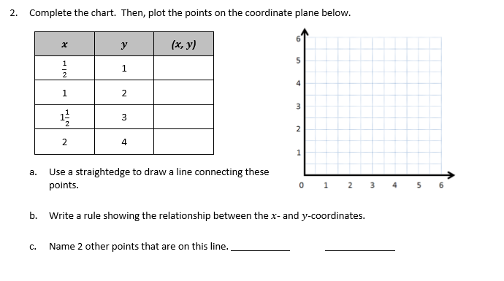

Application Problem:
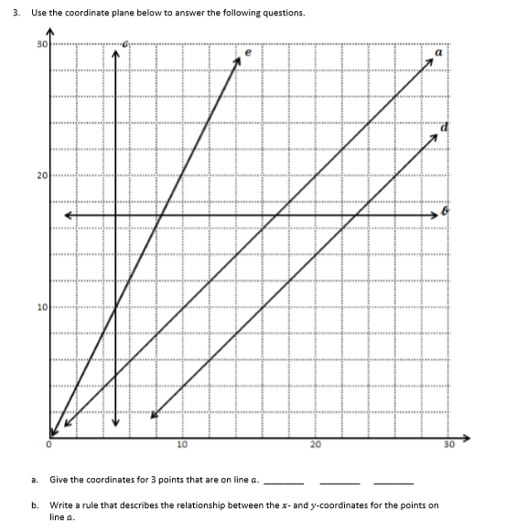

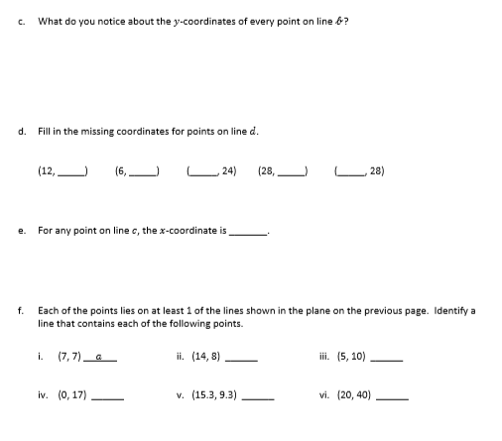

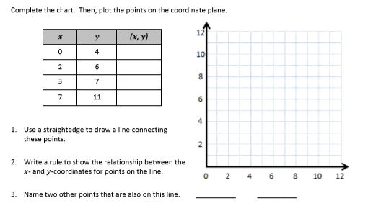
Exit Ticket:

Name ___________________________________________________

5th Grade Modified Math Remote Learning Packet
Week 35

Dear Educator,
My signature is proof that I have reviewed my scholar’s work and supported him to the best of my ability to complete all assignments.

________________________________ ______________________________
(Parent Signature) (Date)
Parents please note that all academic packets are also available on our website at www.brighterchoice.org under the heading “Remote Learning." All academic packet assignments are mandatory and must be completed by all scholars.

Day # 1

Mod 6 Packet 8

Name:__________________________________ Week 35 Day 1 Date:________________
Mod 6 Packet 8
BCCS-Boys Stanford MIT
Do Now
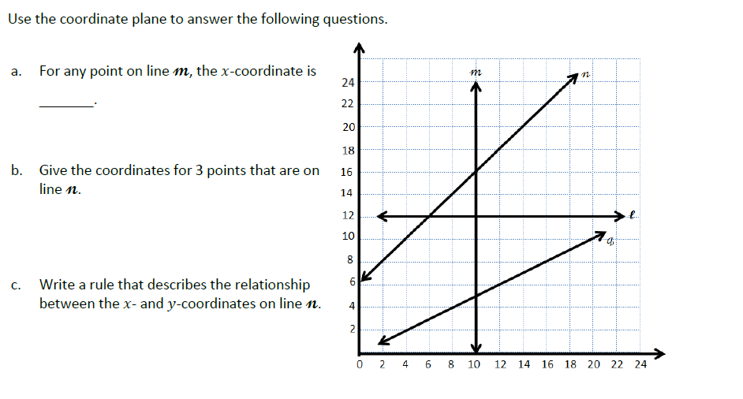

Review:
- Label the x and y axes and label the origin.
- Along both axes, label each interval, counting by ones to five.
- Plot (0,1) on your grid.
- Plot (1,2), (2,3), and (3,4)
- Draw a line through each point you just plotted.
- Write 2 pairs of whole number coordinates on the passing line through the points you plotted.
( , ) and ( , )
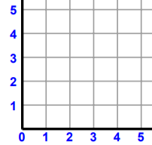

Input Activity
Problem 1
Create coordinate pairs from rules.

- 𝒚 is equal to 𝒙

___________________________________________

- 𝒚 is 1 more than 𝒙

___________________________________________

- 𝒚 is 5 times 𝒙

___________________________________________

- 𝒚 is 1 more than 3 times 𝒙

___________________________________________

- 𝒚 is 1 less than 2 times 𝒙

___________________________________________

Problem 2
Create coordinate pairs from rules, and plot the points.
Line 𝓪: 𝒚 is 2 more than 𝒙.
Rules
Line 𝓫: 𝒚 is 2 times 𝒙.
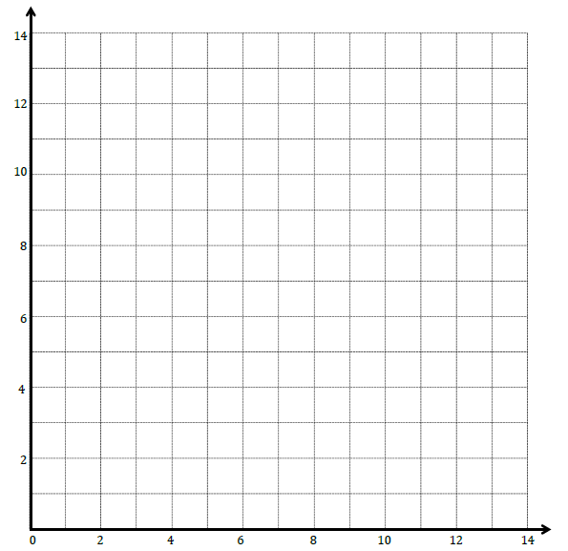
Line 𝓬: 𝒚 is 1 more than 𝒙 doubled.
- Record the rule for line a in chart a.
- What range of values does our axes show?
- What will you need to think about as you pick your values for x?
- Let’s plot three points on your grid.
- Use a straight edge to draw line a.
- Let’s repeat steps 1-4 for line b and line c.
- Which lines appear to be parallel? ___________________________
- Do any lines intersect?__________
- Which lines intersect?___________
- What is the coordinate pair for the point at which they intersect?
_____________________________
- Give the coordinate pair where line a and c intersect_________________

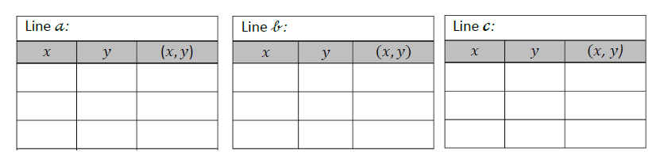
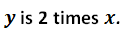
0
0
0
6
3
7
4
8
3
Problem 3
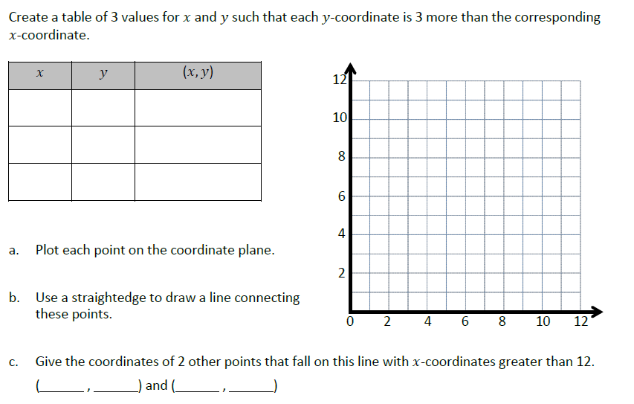
5
3
1
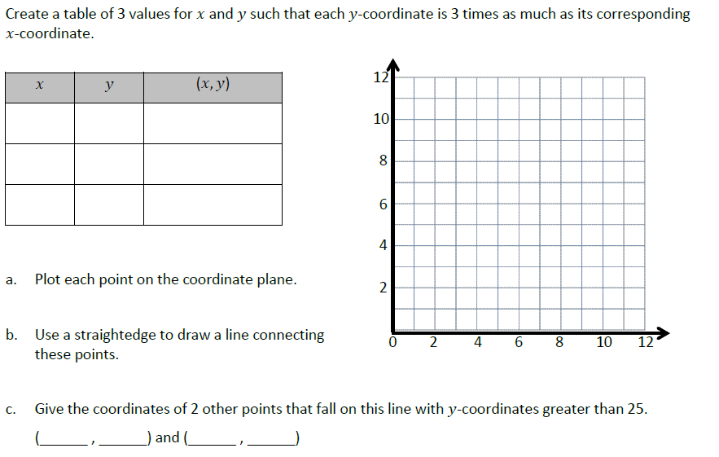
Problem 4

Problem 5
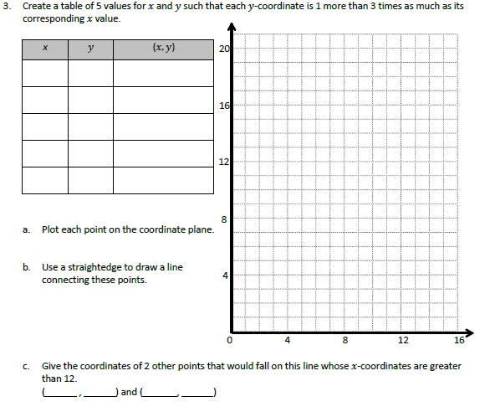

1
2
3
4
5

Problem Set
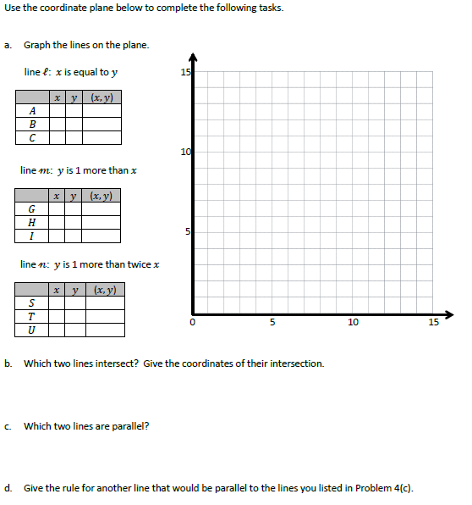

Application Problem:

The coordinate pairs listed locate points on two different lines. Write a rule that describes the relationship between the 𝑥- and 𝑦-coordinates for each line.

Line ℓ: ($3\frac{1}{2}$, 7), ($1\frac{2}{3}$, $3\frac{1}{3}$), (5, 10)

Rule: _________________________________

Line 𝓂: ($\frac{6}{3}$, 1), ($3\frac{1}{2}$, $1\frac{3}{4}$), (13, $6\frac{1}{2}$)

Rule: _________________________________

Exit Ticket
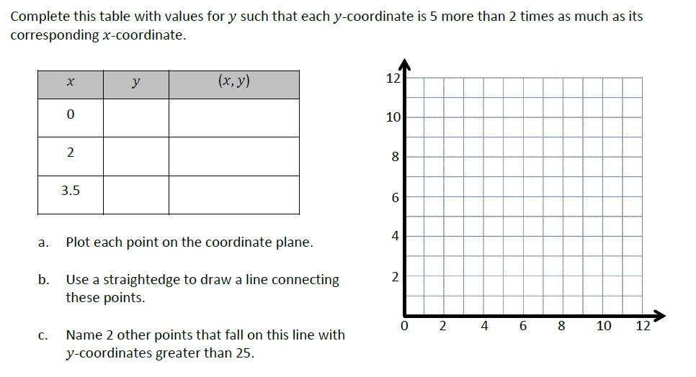

Day # 2

Mod 6 Packet 9

Name:__________________________________ Week 35 Day 2 Date:________________
Mod 6 Packet 9
BCCS-Boys Stanford MIT
Do Now
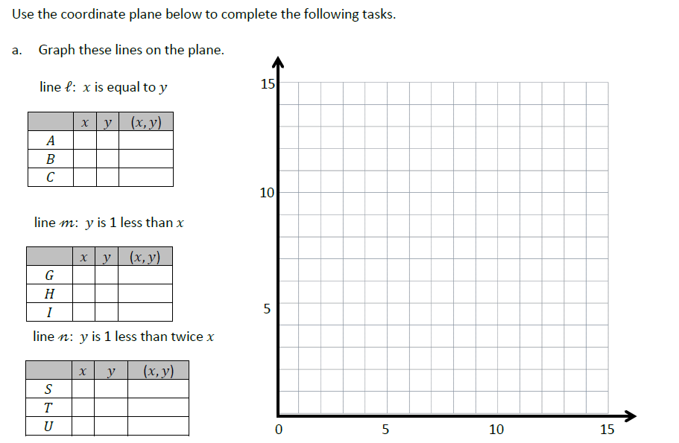

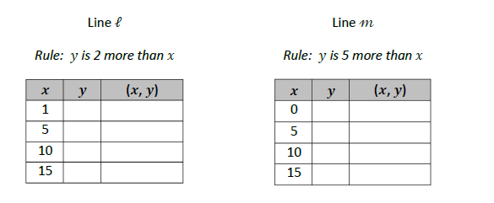
Problem 1:

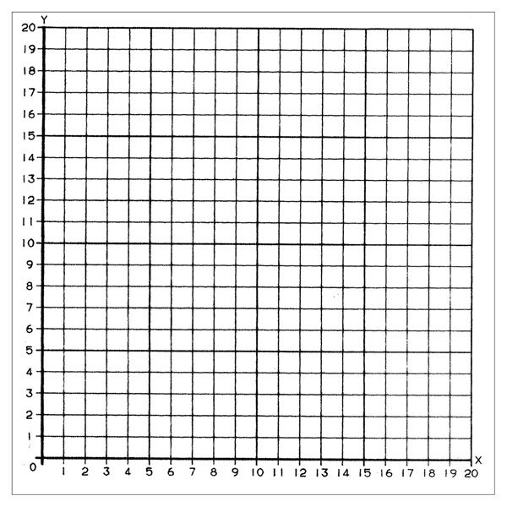

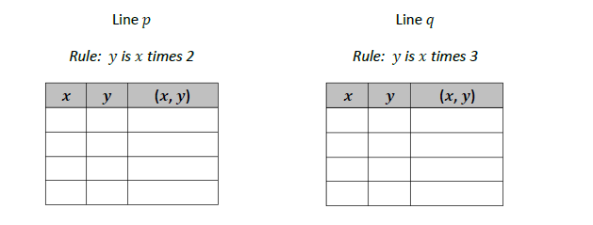
Problem 2:

3
1
2
4
6
5
8
6

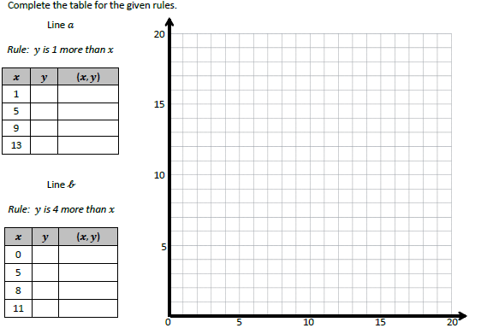
Problem 3:

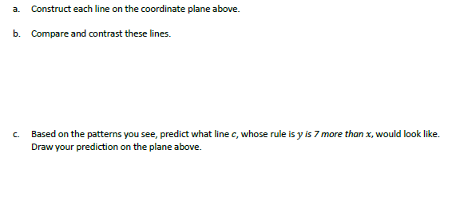

Problem Set:
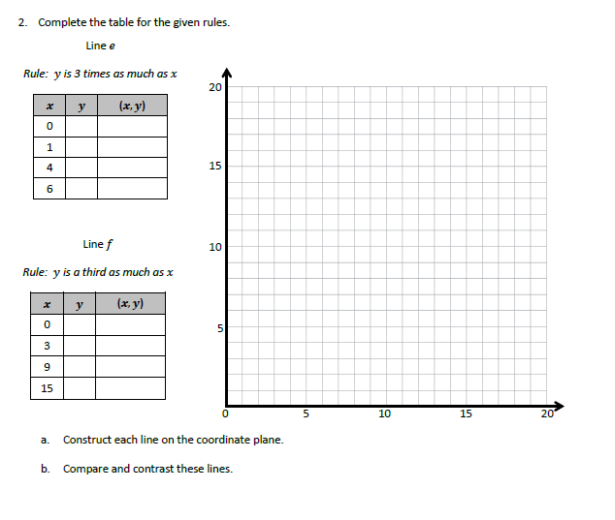

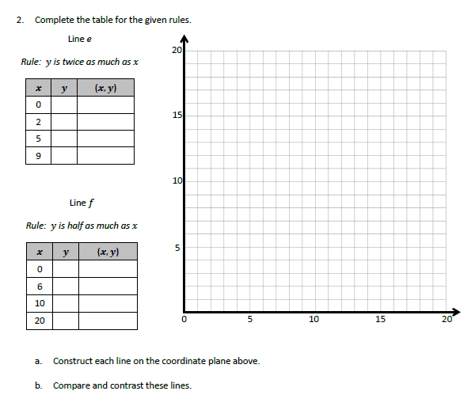
Application Problem:

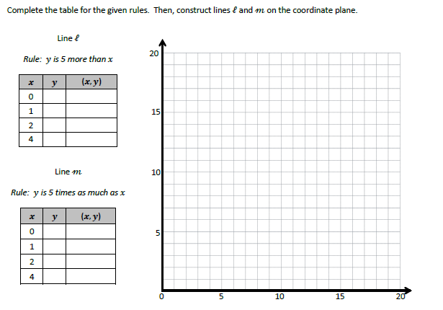
Exit Ticket:

Day # 3

Mod 6 Packet 10

Name:__________________________________ Week 35 Day 3 Date:________________
Mod 6 Packet 10
BCCS-Boys Stanford MIT

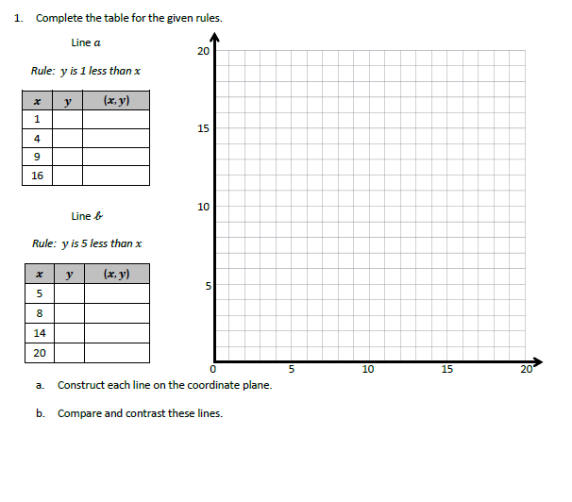
Do Now

Problem 1:
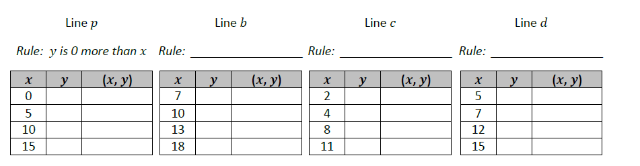

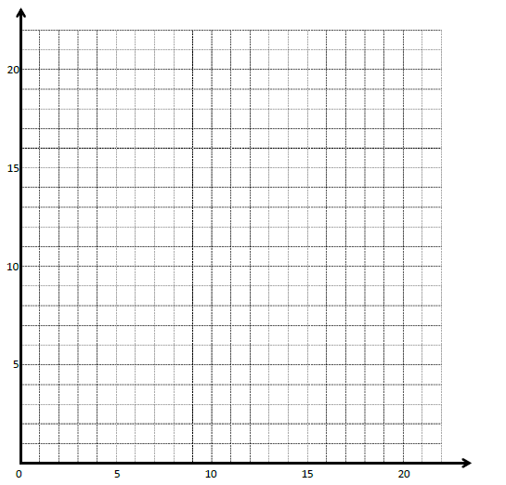

Problem 2:
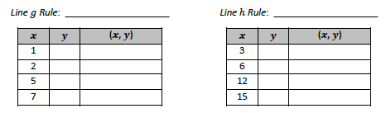

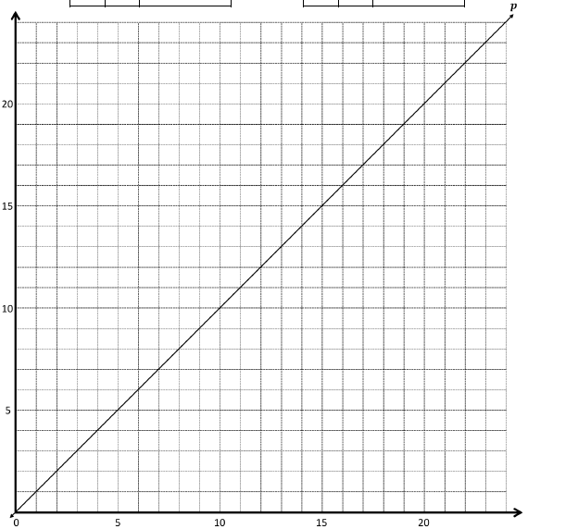

Problem 3:
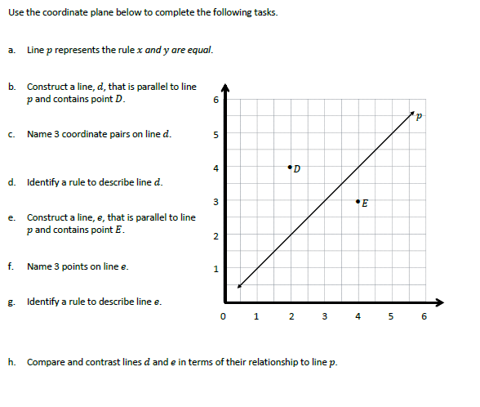

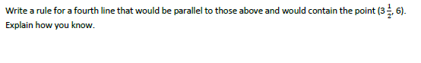

Problem Set:
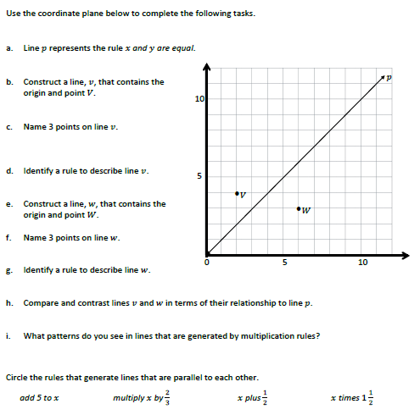

Application Problem
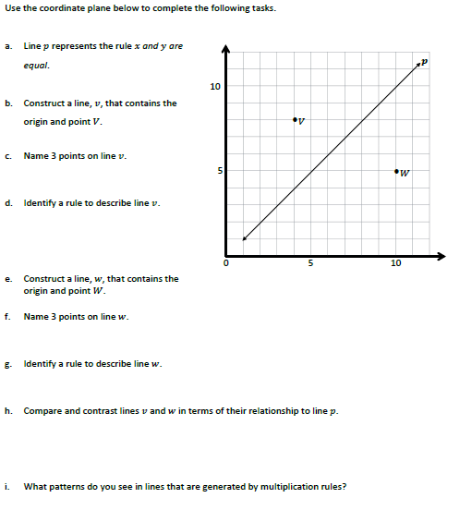

Exit Ticket:
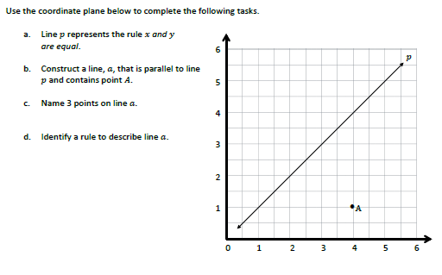

Day # 4

Mod 6 Packet 11

Name:__________________________________ Week 35 Day 4 Date:________________
Mod 6 Packet 11
BCCS-Boys Stanford MIT

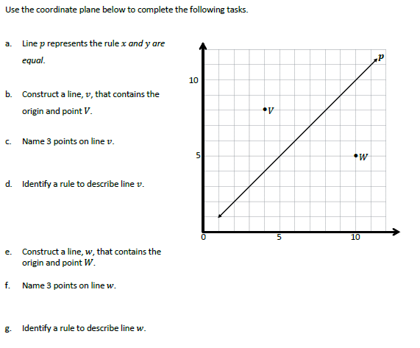
Do Now

Input Activity:
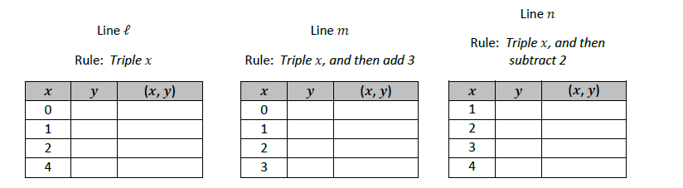
Problem 1:

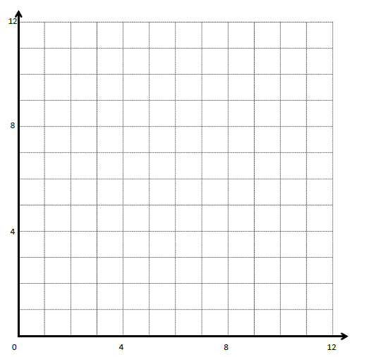

Problem 2:
Rule: y is $\frac{3}{4}$ more than x times $\frac{1}{2}$
X | Y | (x,y)
1
$$1\frac{1}{2}$$
$$\frac{3}{4}$$
$$2\frac{1}{4}$$

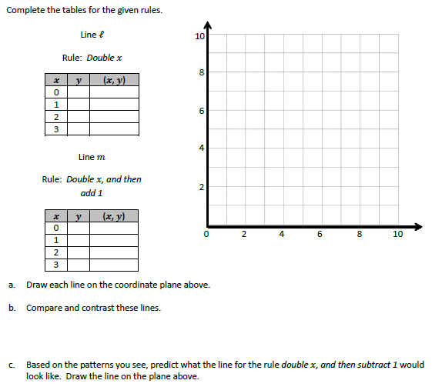
Problem 3:

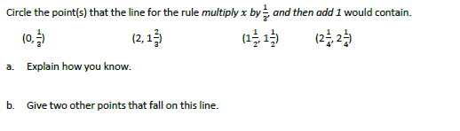

Problem Set:
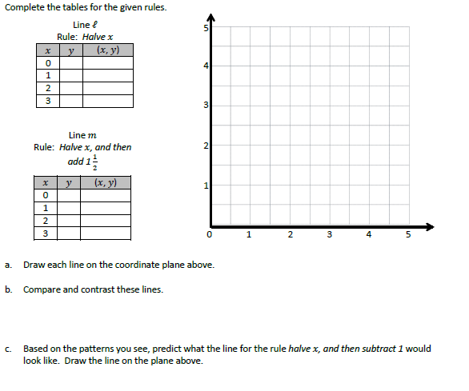

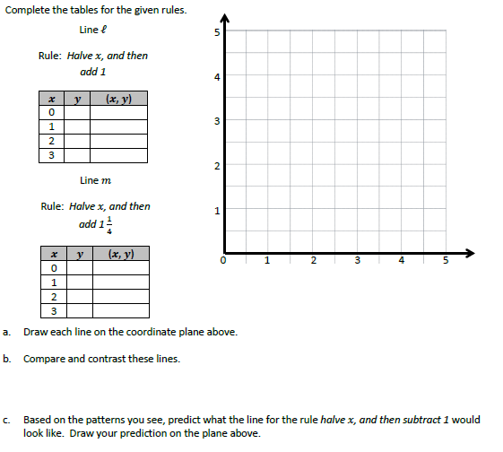
Application Problem:

Exit Ticket:
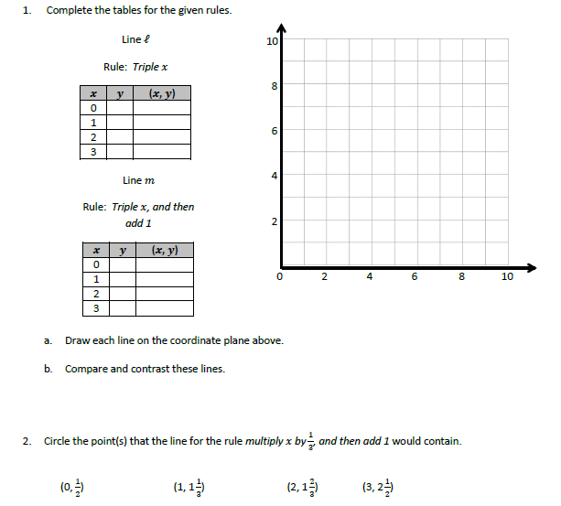

Day # 5

Mod 6 Packet 12

Name:__________________________________ Week 35 Day 5 Date:________________
Mod 6 Packet 12
BCCS-Boys Stanford MIT
Do Now
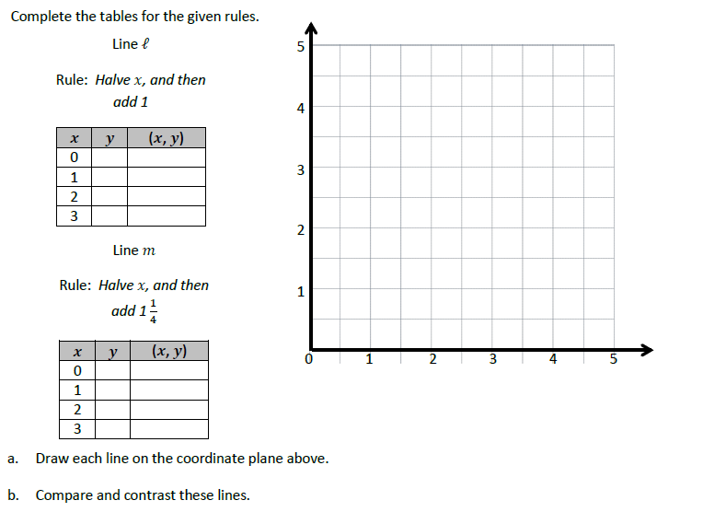

2

Input Activity:
Problem 1:
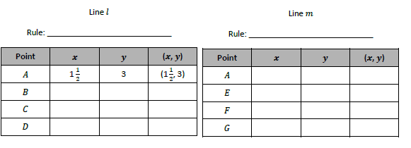

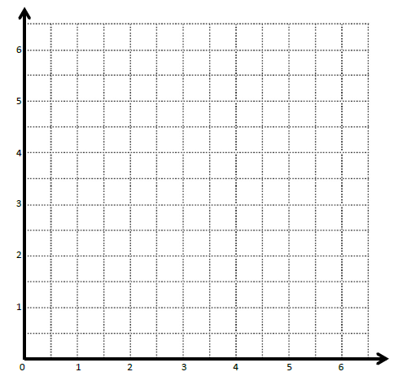
$$6\frac{1}{2}$$

$$5\frac{1}{2}$$

$$4\frac{1}{2}$$

$$3\frac{1}{2}$$
$$2\frac{1}{2}$$

$$1\frac{1}{2}$$

$$\frac{1}{2}$$
$$4\frac{1}{2}$$
$$6\frac{1}{2}$$
$$4\frac{1}{2}$$
$$3\frac{1}{2}$$
$$2\frac{1}{2}$$
$$\frac{1}{2}$$
$$1\frac{1}{2}$$
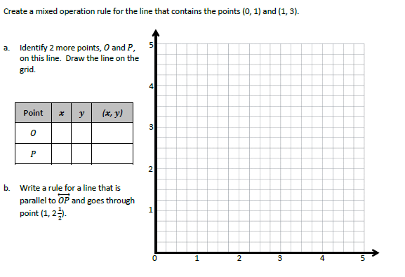
Problem 2:

Problem 3:
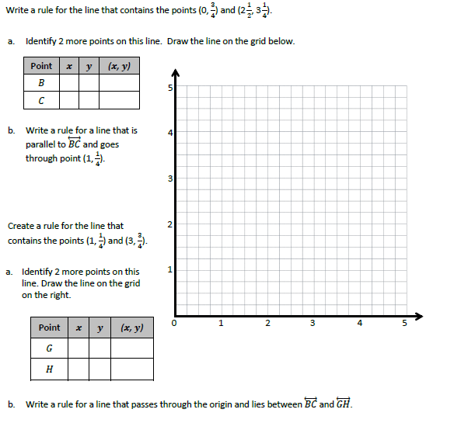

$$4\frac{3}{4}$$
$$4\frac{1}{2}$$
$$4\frac{1}{4}$$
$$3\frac{3}{4}$$
$$3\frac{1}{2}$$
$$3\frac{1}{4}$$
$$2\frac{3}{4}$$
$$2\frac{1}{2}$$
$$2\frac{1}{4}$$
$$1\frac{3}{4}$$
$$1\frac{1}{2}$$
$$1\frac{1}{4}$$
$$\frac{3}{4}$$
$$\frac{1}{2}$$
$$\frac{1}{4}$$

Problem Set:
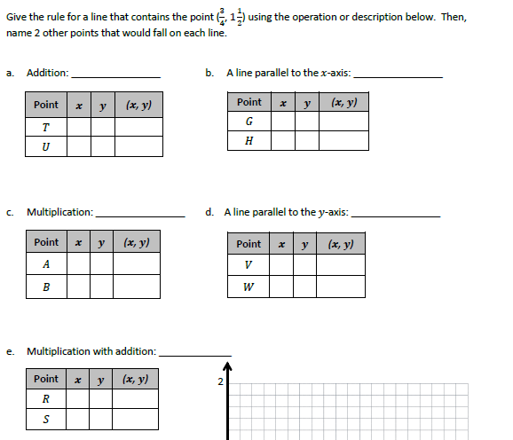
$\frac{1}{2}, 1\frac{1}{2}$)

Application Problem:
Andrew drew the following rocket on the grid below. He handed the grid to you, his partner, to write the coordinates for each point of Andrew’s rocket. Using the rocket grid, write down the coordinates of each point.
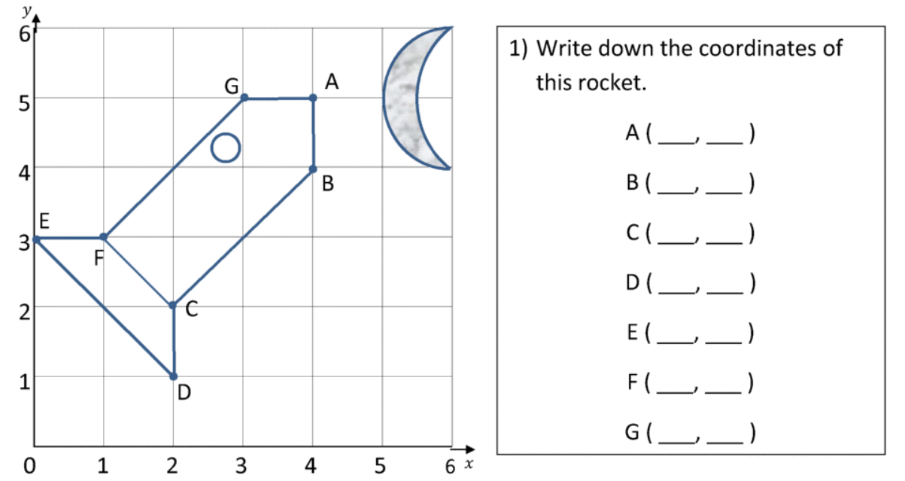

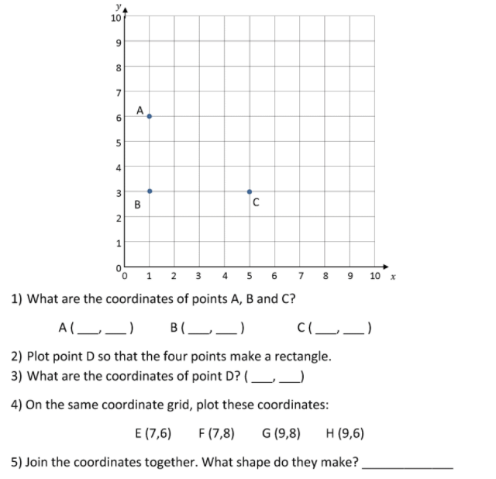
Exit Ticket:

