Name ___________________________________________________

5th Grade Modified ELA Remote Learning Packet
Week 34

Dear Educator,
My signature is proof that I have reviewed my scholar’s work and supported him to the best of my ability to complete all assignments.

________________________________ ______________________________
(Parent Signature) (Date)
Parents please note that all academic packets are also available on our website at www.brighterchoice.org under the heading “Remote Learning." All academic packet assignments are mandatory and must be completed by all scholars.

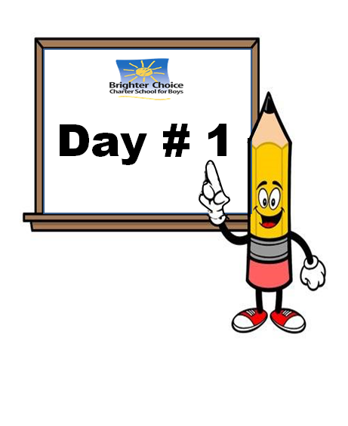
Name: ____________________________ Week 34 Day 1 Date: __________________
BCCS Boys MIT/Stanford

Do Now
- Come up with your own definition of “natural disaster”. ________________________________________________________________________________________________________________________________________________________________________________________________________________________
- List at least three examples of natural disasters: ________________________________________________________________________________________________________________________________________________
- Have you even been through one? Explain. ________________________________________________________________________________________________________________________________________________________________________________________________________________________

Module 4: Natural Disasters
Standard | RI.5.1: Make inferences based on text.  W.5.8: Recall relevant information from text to use in writing.
LEQ | What is the physical impact of natural disasters?
Objective | I can ____________ ___________________ about natural disasters from images, texts, and videos.
Assignment to Submit | Nearpod

Vocabulary Notes:
 | Infer | Public Service Announcement (PSA) | Natural Disaster
Definition | To make ______________ guesses based on evidence and reasoning. | An announcement made for the ________ of the ____________. | A _______________ event such as a flood, earthquake, or tornado that causes great _________________ or loss of life.
Image | 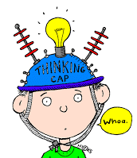 |  | 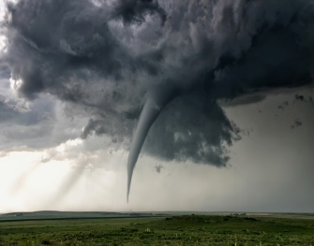

Poetry Video Notes: What will we be learning about in this module?
 | “Hurricane Katrina: Superdome Poem”  Teacher Model | “Voices from Haiti: Job”  Guided Model
I notice…
(things I heard or saw)
I wonder…
(questions I have)

Application: Notice/Wonder Gallery Walk
 | I notice…(things I see) | I wonder…(questions I have)
#1
#2
#3
#4
#5
#6
#7
#8

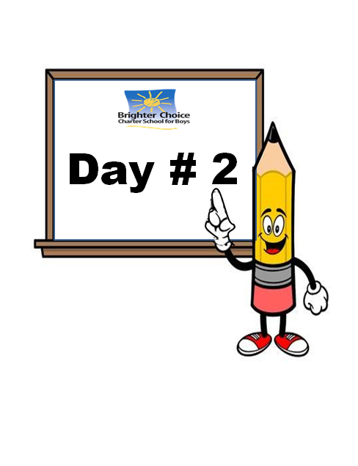

Name: ____________________________ Week 34 Day 2 Date: __________________
BCCS Boys MIT/Stanford

Do Now
- Is a house fire an example of a natural disaster? Explain. ______________________________________________________________________________________________________________________________________________________________________________________________________
- What is the purpose of a PSA? ______________________________________________________________________________________________________________________________________________________________________________________________________

Module 4: Natural Disasters

Standard | W.5.7: Conduct short research projects that use several sources.  W.5.8: Recall relevant information from text to use in writing.
LEQ | What is the physical impact of natural disaster?
Objective | I can cite ________________________ from a source to support my answers to my research question.
Assignment to Submit | Nearpod  My Nearpod code: ___________________________________

 | Credible | Affect | Relevant
Definition | Able to be _________________;  Convincing. | Have an effect on; make a _____________ to. | Closely connected or _________________ to what is being done.
Image | 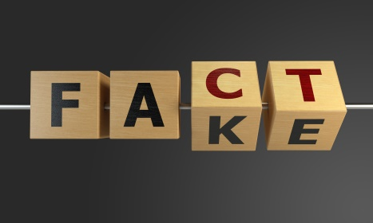 | 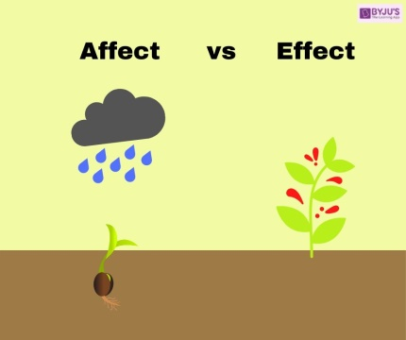 | 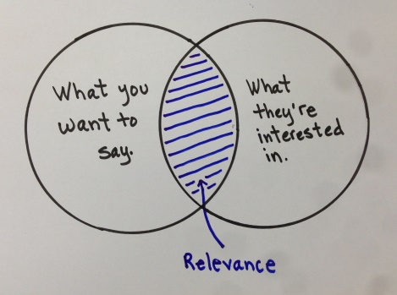
Vocabulary Notes:

Write/Share: How do natural disasters affect the people and places that experience them?
____________________________________________________________________________________________________________________________________
Directions: Today you will be conducting research based on the natural disaster that you chose. I will model what to do. Here are the steps:
- Watch the video provided one time.
- Take notes by answering the questions in your notecatcher.
- Watch the video a second time.
- Complete your notecatcher with any information you may have missed.
- Put a star next to three details that you consider the most important.
- Group up with your peers.
- Take turns sharing relevant details.
Watch as I model these steps.

Research Notecatcher: For YOUR research only (not Teacher Model)
How do natural disasters affect the people and places that experience them?
The natural disaster I am researching is:
Today’s Source is:
Describe the natural disaster. What causes it? What happens during it?

Describe the effects of the natural disaster. What can happen because of it?

How can we stay safe during it?

Other relevant facts:

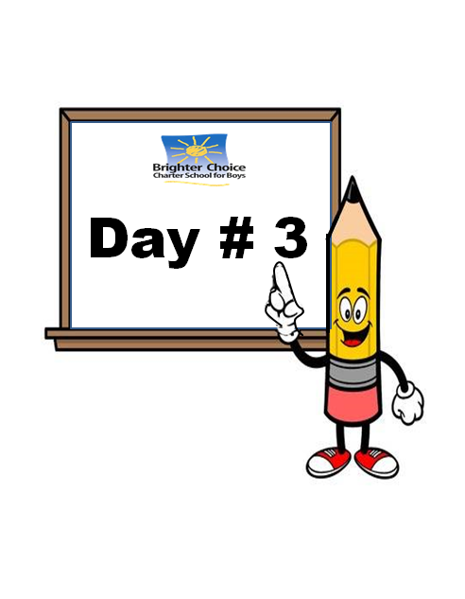

Name: ____________________________ Week 34 Day 3 Date: __________________
BCCS Boys MIT/Stanford
Do Now
- Explain how your natural disaster can affect people. _______________________________________________________________________________________________________________________________________________________________________________________________________________

- Explain how your natural disaster can affect places. _______________________________________________________________________________________________________________________________________________________________________________________________________________
Module 4: Natural Disasters

Standard | RI.5.1: Make inferences.  W.5.7: Conduct short research projects.  W.5.8: Recall relevant information from a text to use in writing.
LEQ | What is the physical impact of natural disasters?
Objective | I can ____________________ an informational text closely and take ______________ in order to answer my research question.
Assignment to Submit | Nearpod  My Code: _______________________________________

Step One: Close Read: Complete a close read of your article on the Nearpod.
Step Two: Jot down the gist of each section of text and write the definition of the unfamiliar words (use the internet if you need to).
Text Section | Gist:  What is it mostly about? | Unfamiliar Vocabulary  *at least 1 per section | Meaning
Introduction

Step Three: Think about our research question and complete the notecatcher based on your article. Be prepared to share out what you find relevant.
Research Notecatcher: For YOUR research only (not Teacher Model)
How do natural disasters affect the people and places that experience them?
The natural disaster I am researching is:
Today’s Source is:
Describe the natural disaster. What causes it? What happens during it?

Describe the effects of the natural disaster. What can happen because of it?

How can we stay safe during it?

Other relevant facts:

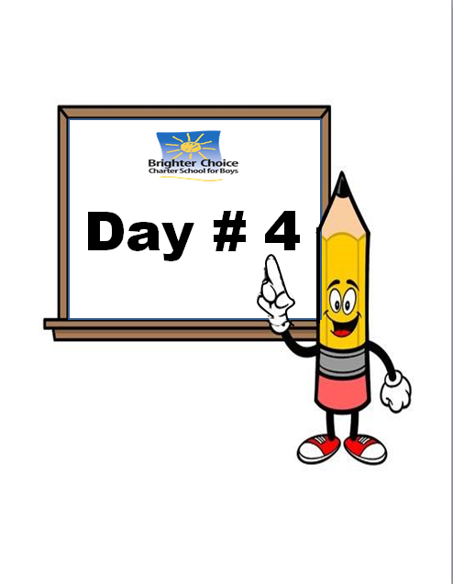
Name: ____________________________ Week 34 Day 4 Date: __________________
BCCS Boys MIT/Stanford
May SPA
Directions: Read the following passages closely and answer the questions that follow. Be sure to use close-reading strategies and RISE.
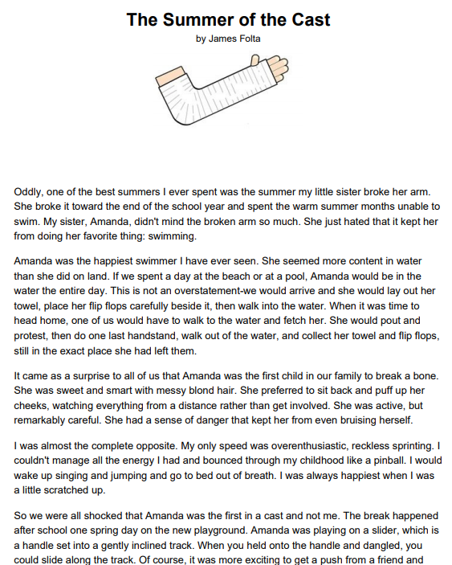
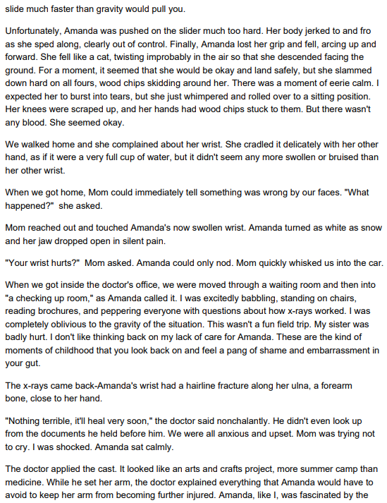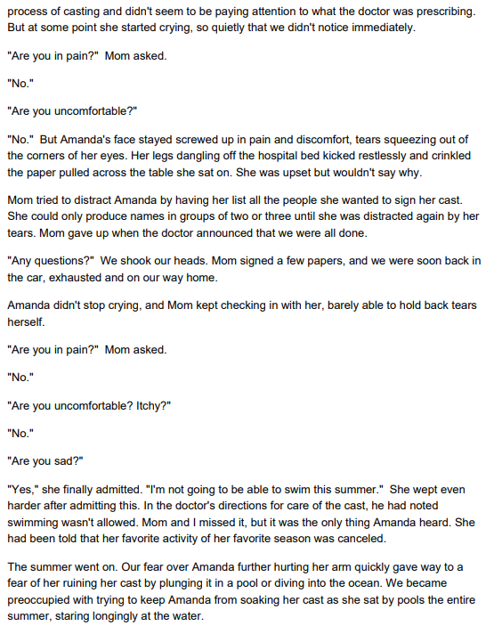

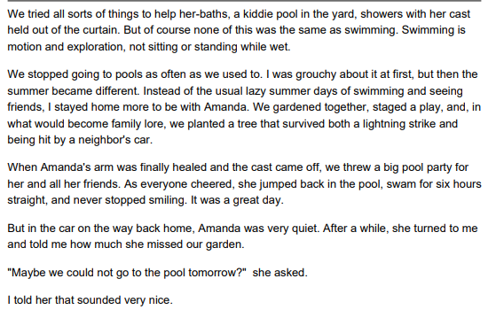__________________________________________________________________
- What main problem does Amanda face in the story? RL.5.2
- She does not get along with the rest of her family.
- She does not want to leave the beach at the end of the day.
- She cannot manage all of the energy she has.
- She cannot go swimming because she broke her arm.

- When she has her cast on, Amanda misses swimming. What evidence from the story best supports this conclusion? RL.5.1
- At the pool, Amanda stares longingly at the water.
- Amanda’s family stops going to the pool as often.
- Amanda staged a play and planted a tree.
- Amanda’s family throws a pool party for her and her friends.

- Why does Amanda start crying at the doctor’s office? RL.5.1
- because she is in a lot of pain
- because she can’t think of anyone to sign her cast
- because she is tired and wants to go home
- because she won’t be able to go swimming

- What is the story mostly about? RL.5.2
- A girl who breaks her arm on the playground.
- Two siblings learn to love swimming over the course of a summer.
- A girl who loves swimming ends her summer of no swimming with a pool party.
- Two siblings spend more time together when one of them breaks her arm.

- Read the following sentences: "I was excitedly babbling, standing on chairs, reading brochures, and peppering everyone with questions about how x-rays worked. I was completely oblivious to the gravity of the situation. This wasn't a fun field trip. My sister was badly hurt. I don't like thinking back on my lack of care for Amanda."
As used in this sentence, what does the word gravity mean? RL.5.4
- happiness
- discomfort
- seriousness
- excitement

- What is the point of view of “The Summer of the Cast”? RL.5.6
- first person
- second person
- third person limited
- third person omniscient

- If the story were told from Amanda’s perspective, how would it be different? RL.5.6
- We would learn if her sibling was a sister or brother.
- We would learn Amanda’s inner thoughts instead of relying on her siblings’ interpretation.
- We would learn more about swimming.
- We would have a better sense of what the siblings did that summer.

- Is the narrator a dynamic character or a static character? Support your response with 2 details from the story. RL.5.3
__________________________________________________________________________________________________________________________________________________________________________________________________________________________________________________________________________________________________________________________________________________________________________________________________________________________________________________________________________________________________________________________________________________________________________________________________________________________________________________________________________________________________________________________________________________________________________________________________________________________________________________________________________________________

- What is the best theme for this story? Support your response with 2 details from the story. RL.5.2
__________________________________________________________________________________________________________________________________________________________________________________________________________________________________________________________________________________________________________________________________________________________________________________________________________________________________________________________________________________________________________________________________________________________________________________________________________________________________________________________________________________________________________________________________________________________________________________________________________________________________________________________________________________________

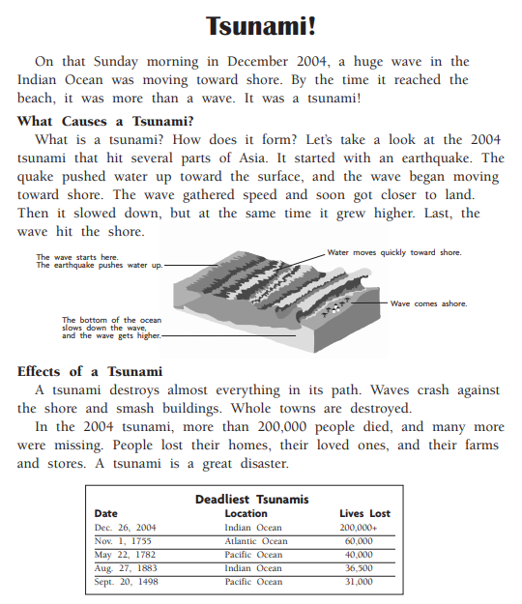

- Which is the best summary of this passage? RI.5.2
- Both the causes and effects of a tsunami can be deadly.
- A tsunami is a series of waves that move toward shore.
- In 2004, an earthquake caused a deadly tsunami in the Indian Ocean.
- A tsunami crashed against the shore and smashes everything.

- In what part of the passage would you look to find out what a tsunami does to the land? RI.5.5
- Effects of a Tsunami
- What Causes a Tsunami?
- Deadliest Tsunamis
- the introduction

- Why does a tsunami slow down as it gets closer to shore? RI.5.1
- The wave grows higher.
- The bottom of the ocean slows it down.
- The surface cools down.
- The wind pushes the water up.

- Using the information from the chart, what can you conclude about the 2004 tsunami? RI.5.1
- It was the deadliest tsunami in the last 500 years.
- The 2004 tsunami did not cause a great amount of damage.
- It was the only tsunami that occurred in the Indian Ocean.
- The 2004 tsunami lasted longer than any other tsunami.
- According to the passage, what is the relationship between a tsunami and an earthquake? Support response with 2 details from the text. RI.5.3
____________________________________________________________________________________________________________________________________________________________________________________________________________________________________________________________________________________________________________________________________________________________________________________________________________________________________________________________________________________________________________________________________________________________________________________________________________________________________________________________________________________________________________________________________________________________________________________________________________

- How does the diagram support your understanding of paragraph 2? Support your response with 2 details from the text. RI.5.1 __________________________________________________________________________________________________________________________________________________________________________________________________________________________________________________________________________________________________________________________________________________________________________________________________________________________________________________________________________________________________________________________________________________________________________________________________________________________________________________________________________________________________________________________________________________________________________________________________

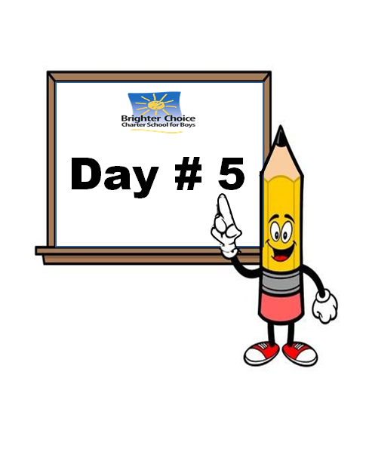

Name: ____________________________ Week 34 Day 5 Date: __________________
BCCS Boys MIT/Stanford
Do Now
- In your opinion, how should communities prepare for your natural disaster? _______________________________________________________________________________________________________________________________________________________________________________________________________________
- Who is responsible for making sure that people are prepared for natural disasters? Why? _______________________________________________________________________________________________________________________________________________________________________________________________________________
Module 4: Natural Disasters

Standard | RI.5.1: Make inferences.  W.5.7: Conduct short research projects.  W.5.8: Recall relevant information from a text to use in writing.
LEQ | What is the physical impact of natural disasters?
Objective | I can read an ___________________________ text closely and take notes in order to answer research questions.
Assignment to Submit | Nearpod

Vocabulary Notes:
 | State Agency | Federal Agency | Private Agency
Definition | An ________________ run by a state government. | An organization run by the _______________ government. | An organization run by an _______________ person or group of people.
Image
What is the point of the article? ____________________________________________________________________________________________________________________________________
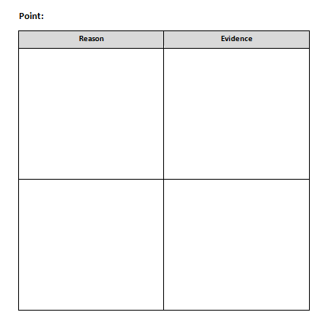

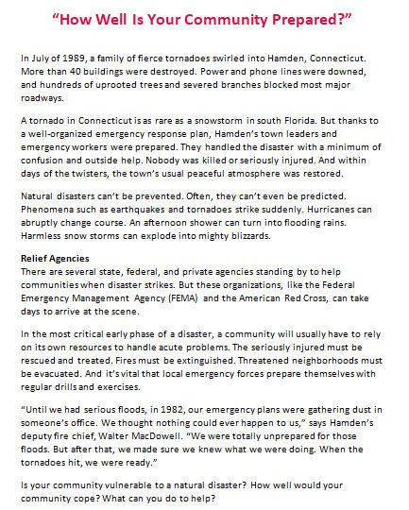
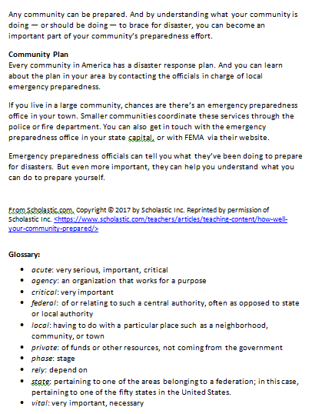

Language Dive: Break down a sentence in order to paraphrase it!
Sentence: But these organizations, like the Federal Emergency Management Agency (FEMA) and the American Red Cross, can take days to arrive at the scene.
But these organizations,
Deconstruct | What is this sentence about?  Why did the author write “But”?
like the Federal Emergency Management Agency (FEMA)
Deconstruct | Why did the author write “like”?  “the Federal Emergency Management Agency (FEMA)” What does this chunk tell us?  Why is FEMA in parenthesis?
and the American Red Cross,
Deconstruct | What does this chunk tell us?
can take days to arrive at the scene.
Deconstruct | What does this chunk tell us about the relief organizations?  Why did the author use the word “can”?  What if we replace “can” with “will”?
Practice | Write about something in your life that could take days to accomplish.
Reconstruct | How can I write this sentence in my own words?  Do you think that is a reason that communities should be prepared or evidence?

Name ___________________________________________________

5th Grade Modified ELA Remote Learning Packet
Week 35

Dear Educator,
My signature is proof that I have reviewed my scholar’s work and supported him to the best of my ability to complete all assignments.

________________________________ ______________________________
(Parent Signature) (Date)
Parents please note that all academic packets are also available on our website at www.brighterchoice.org under the heading “Remote Learning." All academic packet assignments are mandatory and must be completed by all scholars.

Name: ____________________________ Week 35 Day 1 Date: __________________
BCCS Boys MIT/Stanford

Do Now
- Have you used a website for research before? ______________________________
- What are some of the challenges you face when using a website for research? ________________________________________________________________________________________________________________________________________________________________________________________________________________________________________________________________________________________________

Module 4: Natural Disasters
Standard | RI.5.1: Make inferences.  W.5.7: Conduct short research projects.  W.5.8: Recall relevant information from a text to use in writing.  SL.5.1: Engage effectively in discussions with prepared material.
LEQ | What is the physical impact of natural disasters?
Objective | I can use a website to research and prepare for a _______________ ____________.
Assignment to Submit | Nearpod

Research Notecatcher: For YOUR research only (not Teacher Model)
How do natural disasters affect the people and places that experience them?
The natural disaster I am researching is:
Today’s Source is:
Describe the natural disaster. What causes it? What happens during it?

Describe the effects of the natural disaster. What can happen because of it?

How can we stay safe during it?

Other relevant facts:

Teacher Model: Science Talk Graphic Organizer
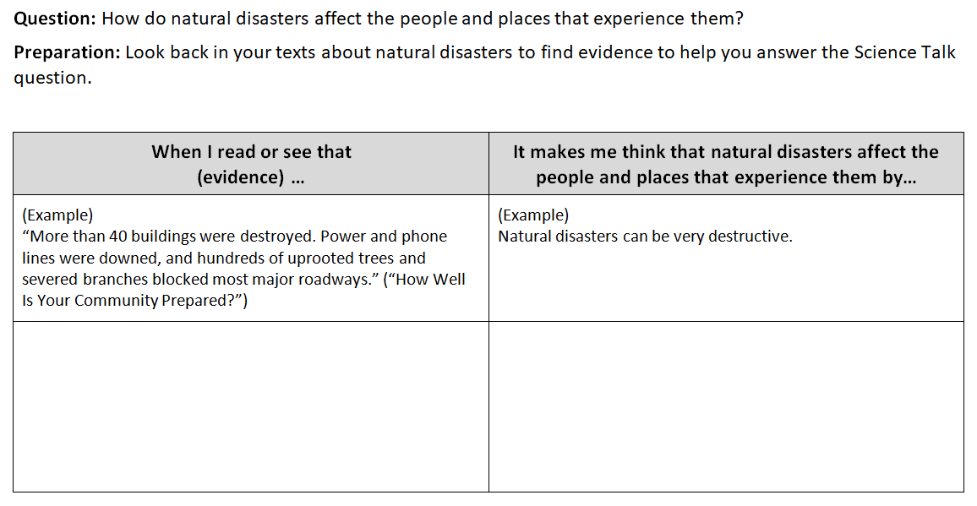

Application: Science Talk Graphic Organizer 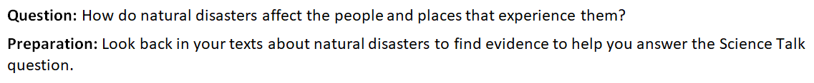
When I read or see that (evidence)… | It makes me think that natural disasters affect the people and places that experience them by…

Name: ____________________________ Week 35 Day 2 Date: __________________
BCCS Boys MIT/Stanford
Mid-Unit Assessment
Directions: Complete a close-read of the article “On Shaky Ground” by Britt Norlander and answer the questions that follow.
Topic: ____________________
Central Idea: _________________________________________________________________
_____________________________________________________________________________

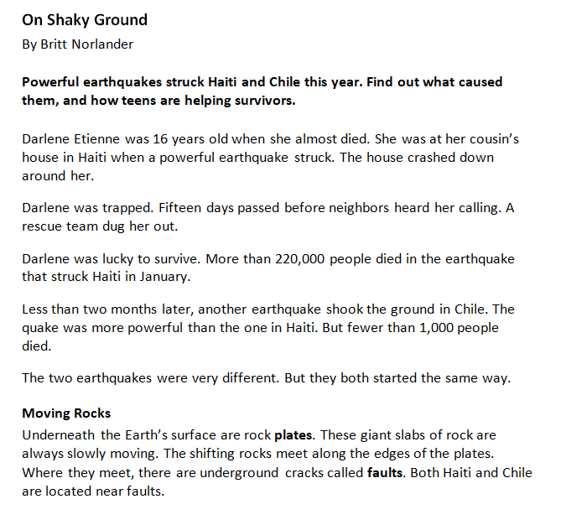

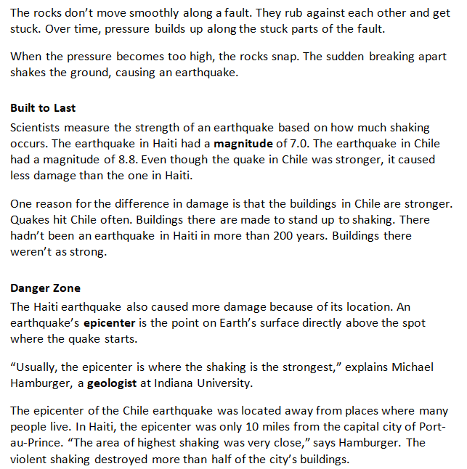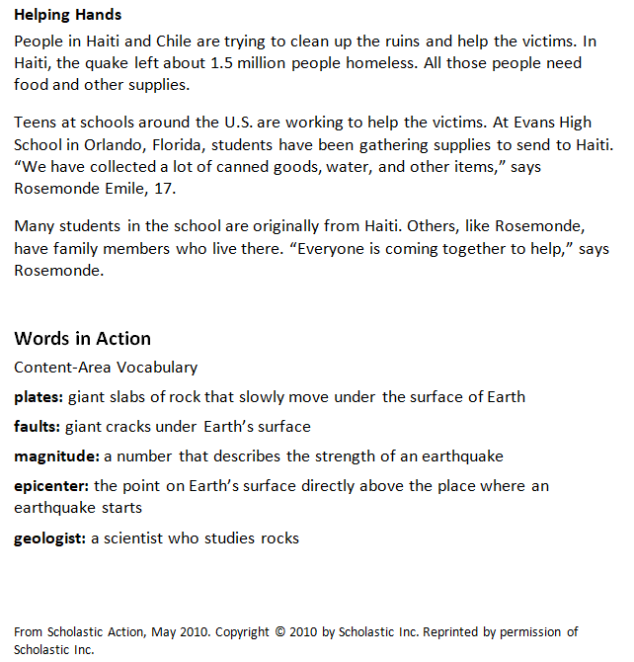

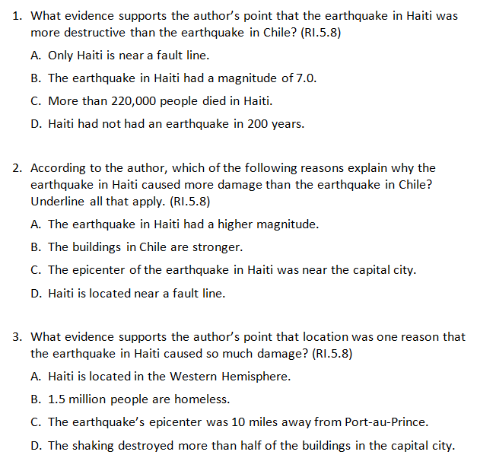

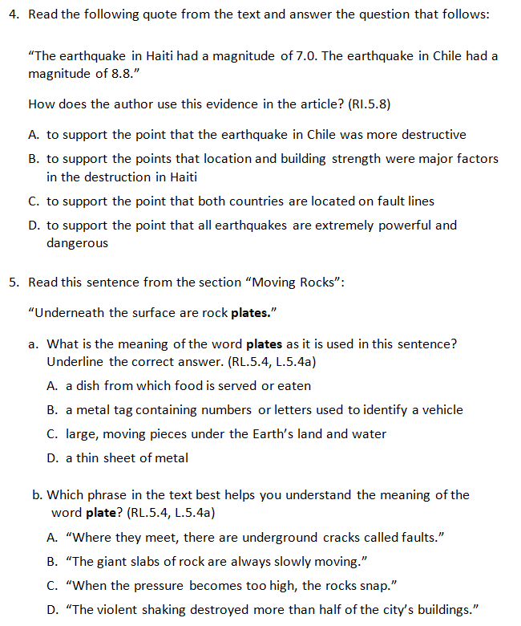

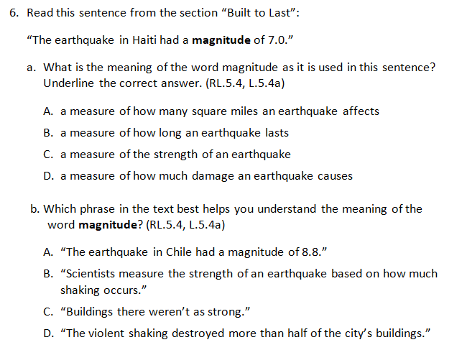

Name: ____________________________ Week 35 Day 3 Date: __________________
BCCS Boys MIT/Stanford

Do Now
- What is a Science Talk? ________________________________________________________________________________________________________________________________________________________________________________________________________________________

- What are you going to talk about in the Science Talk? ________________________________________________________________________________________________________________________________________________________________________________________________________________________

Module 4: Natural Disasters
Standard | SL.5.1: Engage effectively in discussions with prepared material.
LEQ | What is the physical impact of natural disasters?
Objective | I can use a website to research and prepare for a _______________ ____________.
Assignment to Submit | Nearpod

Science Talk Notes and Goals

My Science Talk Notes: Ideas and Questions
Key Ideas:

Science Talk Notes and Goals
My Conclusions:
My Goals for the Next Science Talk:
My Teacher’s Feedback:

Name: ____________________________ Week 35 Day 4 Date: __________________
BCCS Boys MIT/Stanford

Do Now
- What do you think makes a PSA effective? Why? ________________________________________________________________________________________________________________________________________________________________________________________________________________________________________________________________________________________________________________________________________________________________________________________________________________________________________________________________________________________________________________________________________________________________________

Module 4: Natural Disasters

Standard | W.5.2: Write an informative text to convey ideas.  W.5.4: Produce clear writing.
LEQ | What is the physical impact of natural disasters?
Objective | I can ________________ a model in order to generate criteria for an effective PSA.
Assignment to Submit | Nearpod

Natural Disasters PSA Prompt

Task: You have been learning about natural disasters and how they affect the people and places that experience them. Write a script for a PSA raising awareness about staying safe during the natural disaster you researched. Other students, parents, and people in your community will listen to your PSA to learn more about natural disasters.

Directions:
Write a script for a PSA about what someone should do to stay safe during a natural disaster. Be sure to describe the natural disaster and offer some things the audience can do to keep themselves safe. Choose the most important facts and details from your research about your natural disaster. Then write a script that has a clear introduction, facts and details to describe what to do if the disaster occurs and explain how these actions can help to keep someone safe, and a conclusion.

The PSA should:
Be a high-quality product so people trust it
Describe the natural disaster and its impact
Explains that it is important to know what to do if the natural disaster occurs
Suggest some possible actions that can help keep someone safe
Be engaging so that people remember the information
Be no more than one minute long when read aloud

REMEMBER: A well-written informational piece:
Clearly states a focus and stays focused throughout the piece
Use accurate and relevant facts, examples, and details to explain your thinking
Has a short introduction and conclusion
Groups information logically, in a way that makes your thinking clear to the reader.
Follows rules of writing (spelling, punctuation, and grammar)

Characteristics of a PSA
A public service announcement (PSA) is a message directed toward people in a community, used to help them become aware of a social issue
PSAs…
- are high quality.
- use specific vocabulary that get straight to the point.
- are engaging. The audience wants to listen to the end and will remember it.
- use short, simple sentences
- urge the audience to take action by saying: “Do this!” rather than “You could do this.”
- are appropriate for their target audience

*PSAs for children will related to things children are interested in and will feature children.
*PSAs for young adults will relate to things young adults are interested in and contain more complex language and details.
*PSAs for adults will relate to things adults are interested in and will feature adults.
Model PSA

Did you know that almost everyone in the United States can be affected by blizzards and extreme cold? These storms can bring destructive winds, icing, sleet, and freezing rain. They can knock out heat and power for days. Snow and ice can cause serious accidents, and people can get badly hurt from being out in the cold for too long. It’s important to know what to do if a blizzard occurs. Yes, even kids can prepare for blizzards. Here are some things you can do to keep yourself safe.

Before the blizzard, make sure you have an emergency kit, dress warmly, and have extra blankets in case you lose power. Sprinkle sand on sidewalks and walkways outside to help make them less slippery from ice. Be prepared!

During the storm, stay inside if you can. If you have to go outside, wear a hat and mittens, and cover your mouth with a scarf. This will help protect you from the wind and snow. Pay attention to your fingers, toes, ears, and nose—if you can’t feel them or they appear pale white, tell someone. You might have frostbite! Do your best to protect yourself from the bitter cold while the blizzard is happening.

Blizzards sound scary, don’t they? But they don’t have to be! Make sure you have a plan so you know what to do and where to go if there is one. The more you know about blizzards and what to do during one, the better you can deal with it if one happens, and the safer you will be!

Name: ____________________________ Week 35 Day 5 Date: __________________
BCCS Boys MIT/Stanford
Do Now
- What is a PSA? _______________________________________________________________________________________________________________________________________________________________________________________________________________

- How do you write an effect PSA? ____________________________________________________________________________________________________________________________________________________________________________________________________________________________________________________________________________________

Module 4: Natural Disasters

Standard | W.5.2: Write an informative text to convey ideas.  W.5.4: Produce clear writing.
LEQ | What is the physical impact of natural disasters?
Objective | I can plan and begin __________________ a PSA that raises awareness of how to stay safe during a natural disaster/
Assignment to Submit | Nearpod

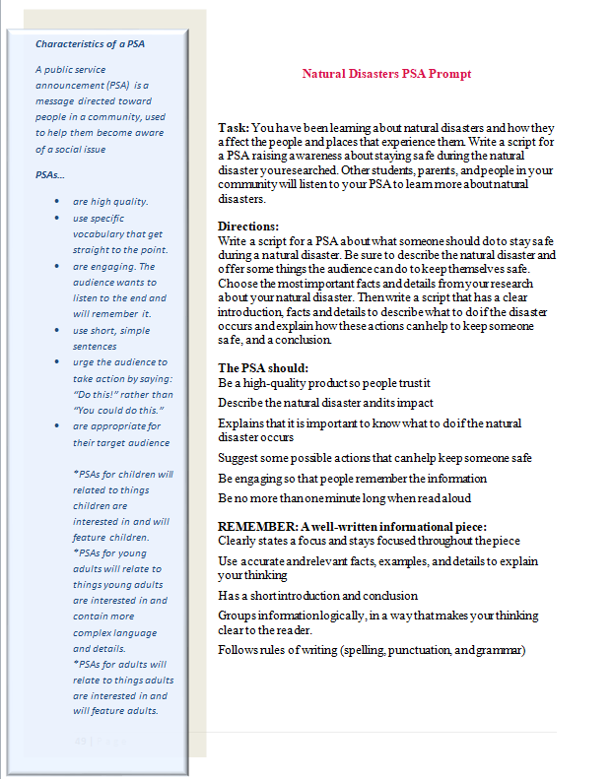
Natural Disaster:

Target Audience:
Introduction
Context about the natural disaster
- share a compelling fact
- briefly describe what it is
Tell why actions needs to be taken:
- How does this disaster affect the people and places that experience it?
Focus Statement: Tell your audience that being prepared is what keeps you safe.
Key Point: | Elaboration: How does that point show how you can stay safe during the natural disaster?

